

**Module Code & Module Title**

**CC4057NP Introduction to Information Systems**

**Assessment weightage & Type**

**60% Group Coursework**

**Year & Semester**

**2024 Autumn**

|  |  |  |
| --- | --- | --- |
| **Student Name** | | **London Met ID** |
| **Darshan Regmi** | | **24041106** |
| **Gaurav Poudel** | | **24044471** |
| **Minham Ale Magar** | | **24042073** |
| **Prajwol Srestha** | | **24044037** |
| **Prajeet Khatri** | **24044480** | |

**Group: C12**

**Assessment Submission: 19th January,2025**

*We confirm that we understand our coursework needs to be submitted online via My Second Teacher under the relevant*

*module page before the deadline for our assignment to be accepted and marked. We are fully aware that late submissions will be treated as non-submission and a mark of zero will be awarded.*

Table of Contents

Introduction 1

Introduction to Project 1

Aims and Objective 2

Aims 2

Objective 3

Tools Used 5

Verdict: 10

Wireframe 11

Name of Pages 13

1. Home Page 13

2. Products Page 15

3. Blog Page 17

4. About Us Page 19

5. Research Page 21

6. Cart Page 23

7. User Profile Page 25

8. Detailed Blog Page 27

9. Detailed Product Page 29

Conclusion 31

• What we used? 31

• What we learned? 31

• Problems we faced. 32

• How we solved the problem? 32

• How the project could be better? 33

Appendix 34

HTML: 34

Home Page (index.html): 34

Product Page (products.html): 65

Blog Page (blog.html): 91

Research Page (research.html): 105

About Us Page (about.html): 123

Cart Page (cart.html): 134

Profile Page (profile.html): 146

Detailed Blog Page (blog1.html): 162

Detailed Product Page (productPage1.html): 180

CSS 193

styles.css: 193

# Introduction

## Introduction to Project

The e-commerce website described in this work was for watch selling. Users would be given the capability to view various watches-ranging from the very expensive to much cheaper ones-on one platform. This platform would allow customers a good experience of selection on a variety of watch categories, with full details on specifications, description, and quality images of each product.  
  
It is also important that the website should have an easy, intuitive interface where a customer can go through different products, filter them by brand, price range, style, and functionality. A user should be allowed to see the detailed pages of every product in depth, where product features, availability, and even customer reviews are included.  
  
Shopping will be easy and secure; the checkout system will be developed to handle customer orders efficiently. It will provide the facility for the user to add items in the shopping cart, review the order, and proceed with a simulated checkout process. The functionality, though the website will not implement a full payment gateway, provides a complete shopping experience, including form-based inputs for customer details.  
  
Apart from the product catalog, there will be other sections on the website, including a blog and a research page that host helpful content pertaining to the world of watches. The blog will provide articles on watch trends, watch maintenance, or how-to guides for buying, whereas the research page will compare models with the intent of helping buyers make informed purchasing decisions.  
  
It will be a fully responsive platform; desktops, tablets, and mobile users shall have a seamless work experience in an interoperable way. Accessible features will be provided to enable use by people with disabilities.  
  
The project will be built using HTML for the website structure, CSS for styling, and JavaScript for dynamic content. Hopefully, these technologies will come together to create an elegant and functional website that will meet the expectations of its users and provide a solid foundation for further expansion.

## Aims and Objective

### Aims

1. Developing a Working E-Commerce Platform for Selling Different Types of Watches: This project's main aim is to build an operational electronic-commerce website that shall specialize in the sale of watches. The website will support various categories of watches, including luxurious, casual, sports, and smartwatches, giving the customer options for choice. The aim is to develop an e-store that is easy to navigate, pleasing to the eye, and simple to use by customers from all walks of life.
2. To provide an organic, esthetically pleasing, and seamless shopping experience: The core of this project is user experience. The design development of the website will have intuitive ways of browsing and spending, clear navigation, high-quality images, and responsive design elements. This is so users find it easy to explore products and complete a purchase efficiently.
3. Demonstrate technical competency in web development with this project by showing technical competency in front-end development technologies such as HTML, CSS, and JavaScript. The project will apply best practices in design, development, and performance optimization to demonstrate expertise in building modern, interactive, high-quality websites.
4. Building a Scalable Platform for Growth: While the website will be very simple in its first version, the architecture will be done to scale. Future enhancements may include customer login, payment gateways, user-generated reviews, personalized recommendations, and others-all without heavy rework.
5. Responsiveness and Accessibility: The trend these days is towards mobile shopping; therefore, the website should be fully responsive. Further, it allows users to comfortably access it using desktops, tablets, and smartphones. For accessibility features that make the website usable for all users, including those living with disabilities, it's high time for inclusion in keyboard navigation, screen reader support, and high-contrast visuals.
6. Safety and Security: Providing the online shopping experience; security features of an e-commerce website have always been its foremost concern. Despite focusing on developing its frontend here, in securing validation forms regarding users' privacy, considerations like the integrity of data in their flow have kept being present on mind when the design must make a user feel safe for each second of their browsing-and-operating time of the website.

### Objective

1. User-Centric Design

* Present the development of an unsophisticated and simple interface: It would enhance easy navigations across different web sections in it by mere motions, smoothly manageable both for any seasoned surfer online and any people with at best rare experiences in electronic purchase operations. Call-to-action buttons like "Add to Basket" or "Proceed with purchase will lead the potential shoppers not to leave any purchasing intention until completing said transaction.
* Suggest a good-looking layout in the following: The website will have a clean, modern design showcasing the product catalog. A minimalist design will reduce clutter to ensure that the focus is on the watches. High-quality images of the watches will be provided, and clear descriptions and specifications alongside them. The color scheme will be consistent with the luxury nature of the products.
* Ensure the Website is Accessible and Usable on All Devices: It will also include a fully responsive platform that can adapt itself automatically to the size of different screens, whether it be on a desktop, tablet, or mobile. It would mean a smooth shopping experience regardless of the device being used. The design principles will be mobile-first, ensuring that the users using smartphones face no friction either. It will also consider accessibility by using easy, readable fonts, proper contrast, and the ability for navigation with a keyboard and a mouse.

1. Features Implemented

* Product Catalog: A diverse catalog of watches will be displayed. Each watch will have a dedicated product page. Every watch in the listing will include necessary information such as price, product pictures, zooming ability, brand name, and a short description. The catalog will be divided into categories such as "Luxury Watches," "Casual Watches," and "Smartwatches," which will make it easier for users to search based on their preferences.
* Search and Filters: The website will also include a search bar at the top where customers can quickly locate watches by typing keywords, brand names, or types of watches. Besides this, filtering can be provided to reduce the number of results in respects to categories such as price range, type of watch-analog, digital, leather, stainless steel-and customer ratings. By doing so, it will provide the results of exactly what the user is searching for with much minimal effort.
* Shopping Cart: The shopping cart will allow users to add items, change the quantity, or remove products with ease. Anytime, users can click on the cart icon to view the contents of their cart. The cart will summarize the selected items in a format that includes product names, quantities, prices, and total cost. With this feature, users are guaranteed to review selections before proceeding to the checkout.
* Checkout Process: The website should provide an easy and safe way to check out. A form for the client will allow reviewing an order and delivery details to finish off a purchase. Because true payment processing does not have to be developed and implemented, it shall be allowed that a form submission will take the place of submitting an actual order. Also, it provides progress indication all through to navigate a user inside this checkout.

1. Technology Usage

* HTML5: HTML5 is to be used in providing the very skeleton of this website. Defining the layout based on semantic elements, including header, footer, main, and section elements helps with search engine optimization as well as makes sure good accessibility for browsers. It can be made up of properly identified forms, buttons, and links so that viewers find it a piece of cake to interact.
* CSS3: Design of the website is done using CSS3, offering an attractive web page design highlighting luxury and class products. Professional layout of a web page can be done in CSS using different methods: a flexible box model and grid models that answer for responsiveness of a web page. Screen-size changing and smoothing will be enabled with the use of media queries for good rendering on mobile, tablet, and desktop. More interactivity and visual flair will also be achieved by including animations and transitions on the site.
* JavaScript:  
  JavaScript will provide interactivity on the website and make it more dynamic. It will also facilitate key functionalities such as the following:
  + Dynamic Product Filters: The facility to filter the products by different attributes such as price, brand, and type without refreshing the page.
  + Form Validation: Check whether all form inputs are correctly filled in upon submission, like the contact details and checkout information. It gives quite a smooth user experience by showing immediate feedback.
  + Interactive Elements: Implement image sliders to show the products from multiple sides, dropdowns to select with the product, or tooltips to provide additional information on some features of the product.

## Tools Used

1. Visual Studio Code:

Description:  
VS Code is an open-source code editor available for multiple operating systems; it was developed by Microsoft. It, however, can extend its support for a wide variety of programming languages, frameworks, and tools. It is important features include the following: IntelliSense for the completion of codes, integration with Git to manage various versions, debugging is possible, and it also houses a terminal inside. In addition, VS Code is lightweight while being highly customizable, with features such as themes, syntax highlighting, and code snippets.  
  
Purpose:  
The development team of an e-commerce site uses Visual Studio Code as an editor for writing or editing source code. It basically makes life easier for the team by embedding linters, formatters, and version control into this single editor. The great rich set of extensions supports a wide array of programming languages, including HTML, CSS, JavaScript, and Python, in support of web application development. It provides Git support in VS Code to manage version control, commit changes, and collaborate more with the changes within a team.  
  
Why chosen:  
We have chosen Visual Studio Code because it is lightweight and can enhance productivity with inbuilt features of Git, debugging, and code navigation. This tool makes sure that collaboration goes on smoothly and saves time to set up by team members.

1. Google Chrome:

Description:  
The other way around, Google Chrome has turned out to be one of the fastest browsers and turned into a reliable and performance-oriented browser. Among all impressive capabilities, Chrome contains built-in developer tools called Chrome DevTools that let a developer inspect changes to HTML and CSS in real-time, debug JavaScript, monitor performance, and analyze network requests. These features turn it into an indispensable utility for a web developer, making sure that web applications run as smoothly as possible, and look great on all types of devices.  
  
Purpose:  
Testing and viewing during the development of the e-commerce platform is done using Google Chrome. It will be used by default when running the platform for compatibility and performance purposes. Chrome’s DevTools are extensively used for debugging issues such as layout problems, JavaScript errors, and slow network responses. With its responsive design mode, the team can test how the platform appears on different screen sizes and devices.  
  
Why it’s chosen:  
Chrome is chosen because of its widespread adoption, speed, and robust developer tools. The team can efficiently monitor, debug, and optimize the platform for all users, ensuring cross-browser compatibility and an overall smooth user experience.

1. GitHub:

Description:  
GitHub is a version control and collaboration platform that uses Git, a free, open-source, distributed version control system. It allows developers to store and manage their code, track changes, collaborate with other developers, and handle issues and tasks. Among others, it offers code review in pull requests, project management in project boards, and continuous integration and deployment in Actions. Further, GitHub can integrate with a variety of third-party tools with the purpose of automating workflows.  
  
Purpose:  
GitHub was used for code sharing, version control, and collaboration. It allowed all members of the team to work on the latest version of the codebase without one overwriting the changes made by another. GitHub allowed them to work on a separate branch, create a pull request for code review before landing to the main codebase. The issue-tracking system built into GitHub keeps things organized-things such as the organization of tasks, bugs, and new features.  
  
Why it is chosen:  
GitHub was chosen because of the powerful version control which, among other advantages, allows for real-time collaboration and easily integrates with other development tools. It can also show the history of changes to the code made by the team and manages projects with issue tracking easily.

1. Instagram:

Description:  
Instagram is a widely used social networking platform that allows its users to publish and share photos, videos, and direct messages. Besides social networking, the features offered with Instagram include the features of Instagram Stories, messaging, and group chats, which are very useful in informal communication and collaboration.  
  
Purpose:  
Instagram means easy, available ways of communication among the team to establish coordination. Instagram is put into use with the aim of providing speedy updates regarding images and progress of projects by the development team. By making dedicated group chats regarding specific topics such as design, coding, or testing, members make sure that communication is effective without formally meeting. Besides this, there are quick visual updates and feedback via Instagram Stories.  
  
Why chosen:  
Instagram would be chosen because it is already done by the group members for social and informal communications. Its usability and sharing of multimedia enable the team members to keep in contact, share their ideas, and give feedback to one another efficiently.

1. Balsamiq Wireframes:

Description:  
Balsamiq Wireframes is a rapid wireframing tool to create low-fidelity, clickable wireframes and user interface mockups of different varieties. It is well applied during the early stages of design in sketching out ideas about what something should look and feel like and how different parts of an application interact. Balsamiq's interface looks like it's hand-drawn, which makes for rapid iteration and quick communication. It provides a simple drag-and-drop editor for placing UI elements such as buttons, forms, and navigation menus.  
  
Purpose:  
Balsamiq Wireframes is used for creating wireframes of the e-commerce platform’s user interface (UI). These wireframes allow the team to visualize the layout, flow, and structure of the platform without investing too much time in detailed design. Wireframes serve as a blueprint for the design and development process, providing a clear understanding of the platform’s functionality and user experience (UX) before coding begins.  
  
Why it's chosen:  
Balsamiq Wireframes because it is very simple, fast, and easy to work with during the early stages of development. Based on this, the tool will let the team have very fast testing and iteration over different design ideas before freezing the UI and passing it for development.

## Verdict:

1. HTML: Hypertext Markup Language  
   HTML is the backbone of a webpage and gives support to the web content. Elements or "tags" are used through a system that dictates how various content-text, images, links, forms, and multimedia-are to be rendered. Each HTML element is defined by opening and closing tags, and these elements build up the foundation of the user interface. HTML provides the static content viewable in any web browser and is thus the basic prerequisite for developing web pages.
2. CSS  
   CSS stands for Cascading Style Sheets and is a stylesheet language used in maintaining the look and feel of how HTML elements should look on your web pages. While HTML does the structuring of the content, its design and layout depend on CSS. In CSS, selectors, properties, and values can be set to outline the elements on colors, fonts, spacing, positioning, and responsiveness. CSS makes it possible for developers to create good-looking websites where a website looks accessible and well-structured on different screen sizes and devices. It abstracts the content from designing and helps update the look and feel of the site without changing the structure.
3. JavaScript (JS)  
   JavaScript is a programming language used for adding dynamism and interactivity on web pages. In JavaScript, these developers, unlike HTML, which was majorly used for content and CSS for presentation, can implement form validation, animation, and real-time updates. It allows the web page to react to user actions such as clicking or pressing keys, and it changes the content of the page or its style dynamically without reload. It is essential to enhance user experience using JavaScript, which is, therefore, used primarily in developing shopping cart systems, data retrieval from APIs, and interaction in modern web applications.

# Wireframe

For creating wireframe, we are using Balsamiq:

Balsamiq is a wireframing tool created to be more user-friendly and to help a team create low-fidelity, interactive mockups of Web and mobile applications. It helps designers, developers, and stakeholders quickly visualize an interface and prototype a UI without getting bogged down in detailed design. It offers a very simple, intuitive drag-and-drop interface where users can choose from its library of prebuilt UI components, including buttons, text boxes, navigation bars, and icons. These elements are intentionally drawn in a crude or "sketch-like" fashion to give wireframes their "hand-drawn" appearance.



Probably one of the most characteristic features of Balsamiq is its power in making fast wireframes for brainstorming and early-stage design discussions easy. Because these are low-fidelity wireframes, this allows the team not to worry about color, font choice, or pixel-perfect visual design but about layout, structure, and functionality of the application. All this makes rapid iterations, testing of different ideas, and early feedback a lot easier during the design process.

It also allows for clickable prototypes; that means the users can simulate the navigation and interactions of an interface to see how a real, finished product might work. That makes this tool great for testing with clients or users who get a close-to-real representation of the flow of an application.

Besides its intuitive interface, Balsamiq enables collaboration, where teams can share wireframes and work with ease. One can export the wireframes in various formats, such as PNG, PDF, or interactive HTML, usable in presentations, discussions, or for further development.

In all, Balsamiq is an effective work tool in the initial design phase that helps teams effectively communicate ideas, flesh out alternatives, and provide a clear direction for the development of a product. Its ease, speed, and collaboration features make it a very valuable instrument for designers and developers who need to efficiently create user-centered interfaces.

## Name of Pages

1. Home Page: This is the landing section, and it features a banner to introduce our store, featured products to show case out most popular products, a section to show the most recent blogs and articles, a section for costumer’s review and a section to give customer reasons to choose us.

**Wireframe**:

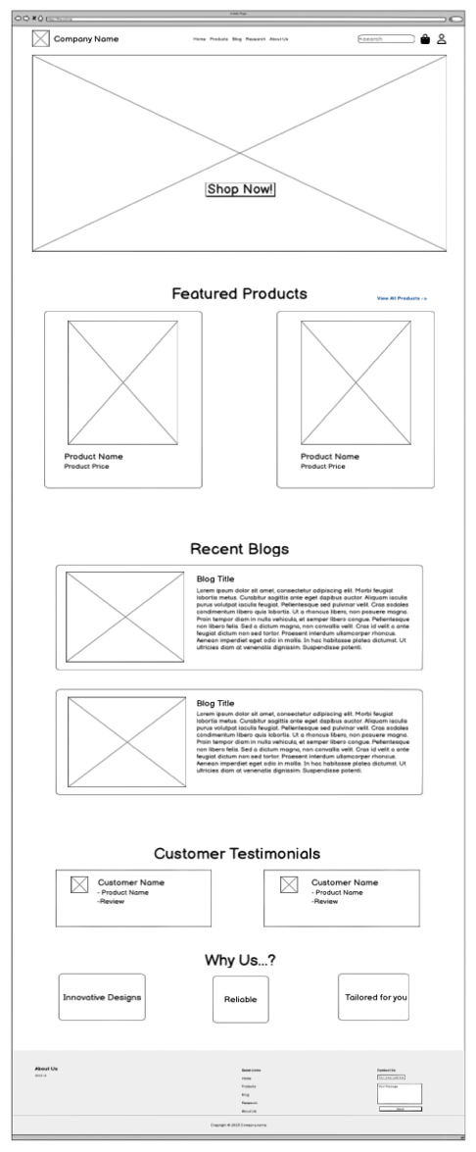

**Website:**

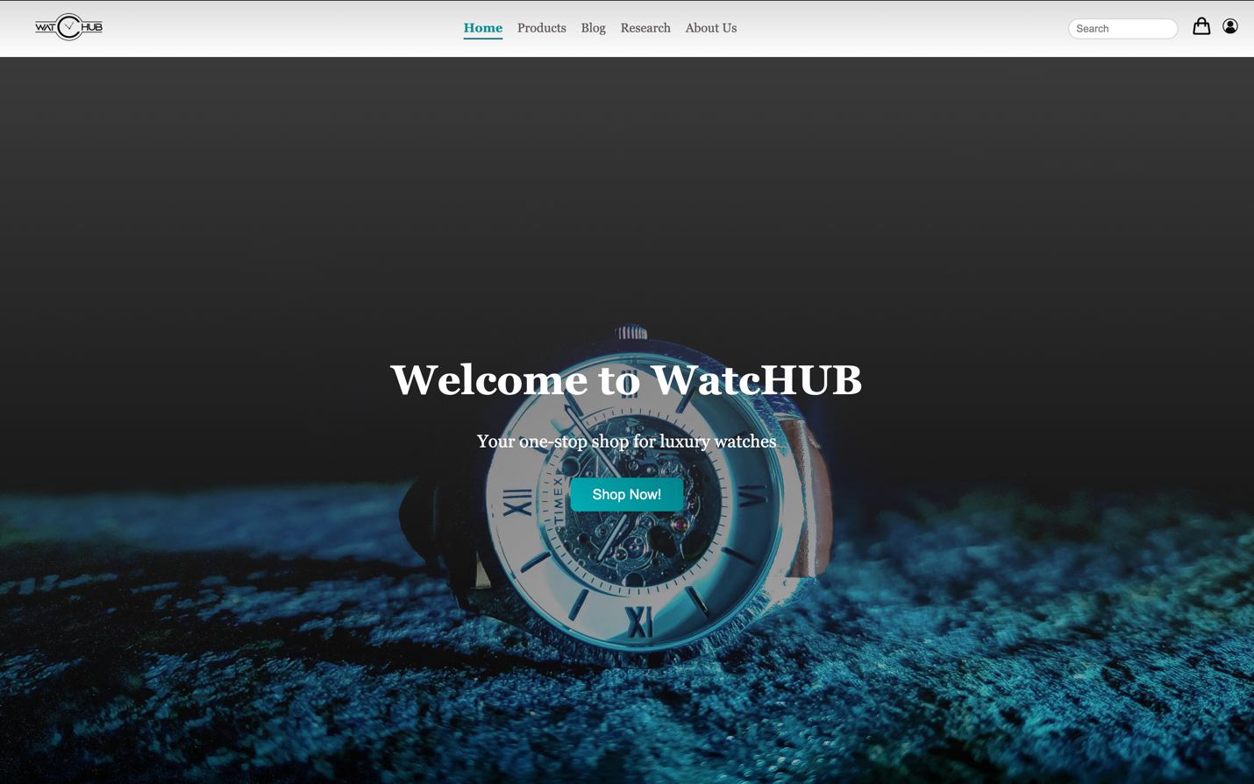

1. Products Page: In this section we show our products and give customer a varity of products to chose form.

**Wireframe:**

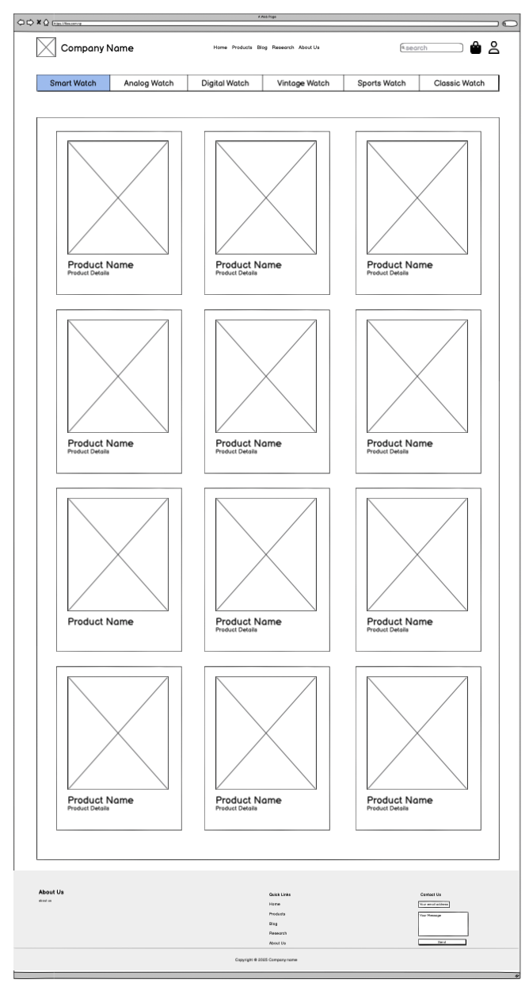

**Website:**

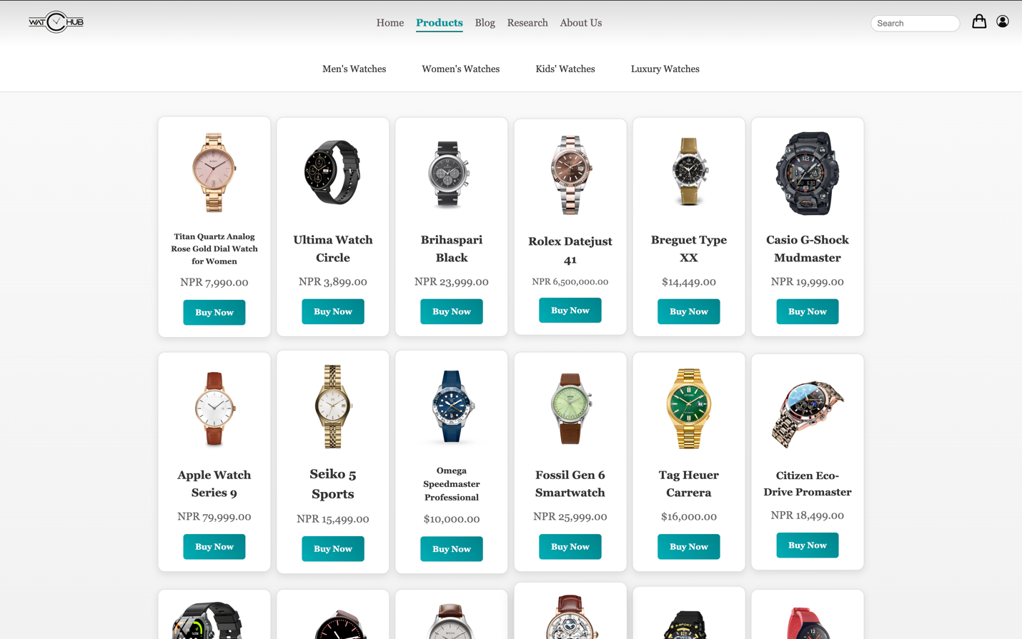

1. Blog Page: This is the section where we post our latest and new breaking articles and blogs for our customers to read and enjoy.

**Wireframe:**

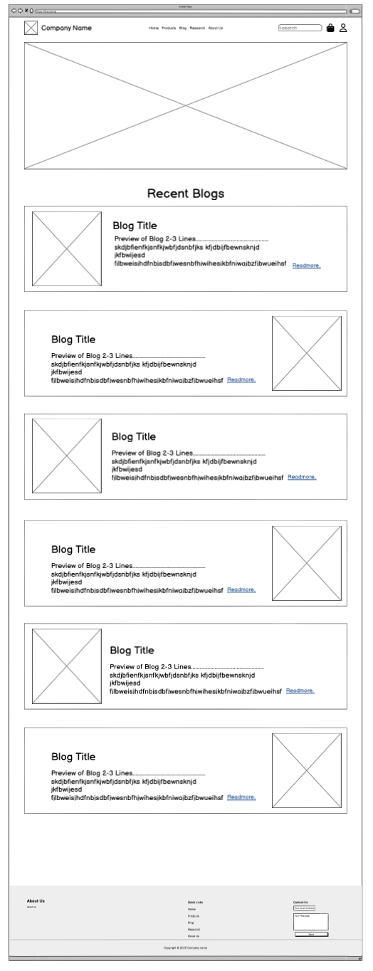

**Website:**

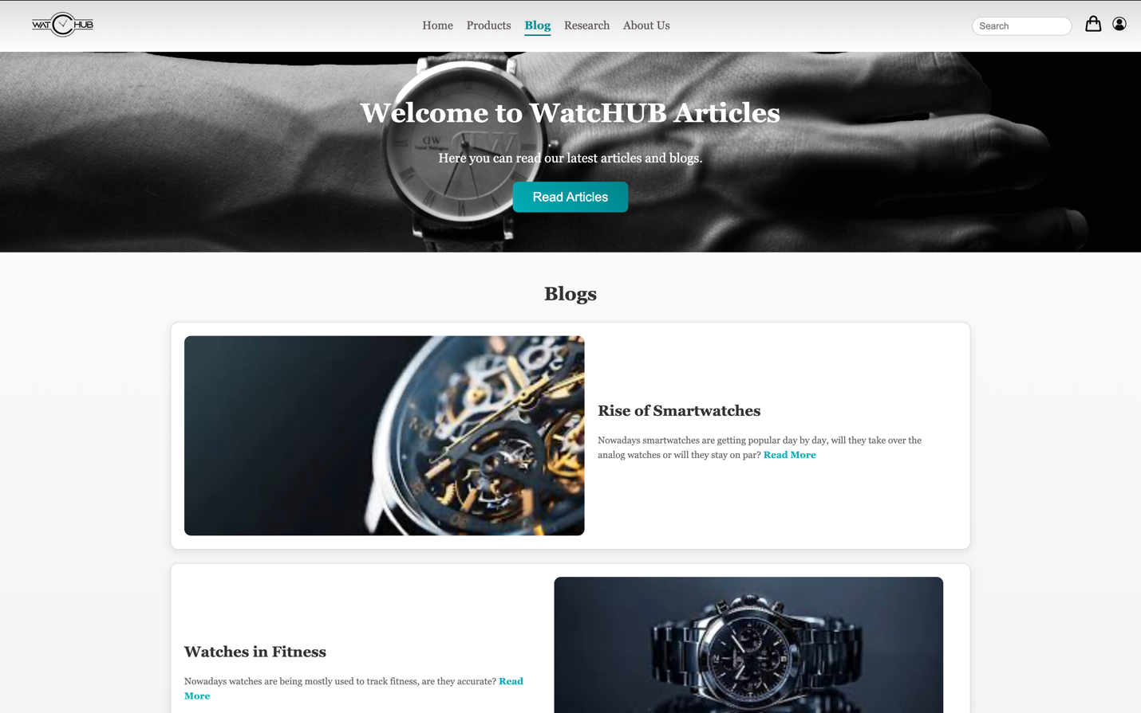

1. About Us Page: This is the section where we introduce our company and our team members who have helped us in various other ways.

**Wireframe:**

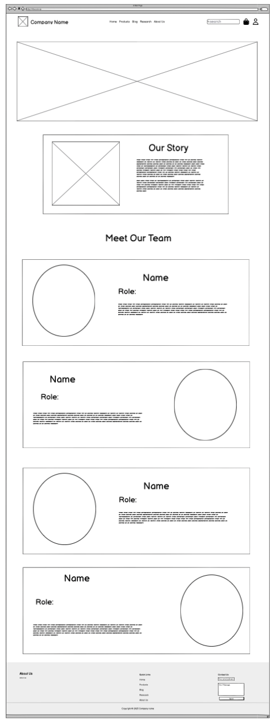

**Website:**

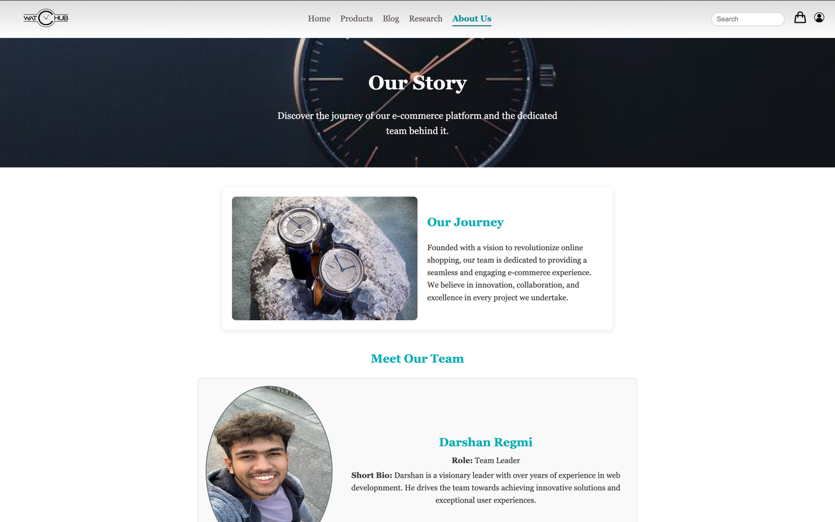

1. Research Page: This is the section where we share our research while building the page and the resources we used.

**Wireframe:**

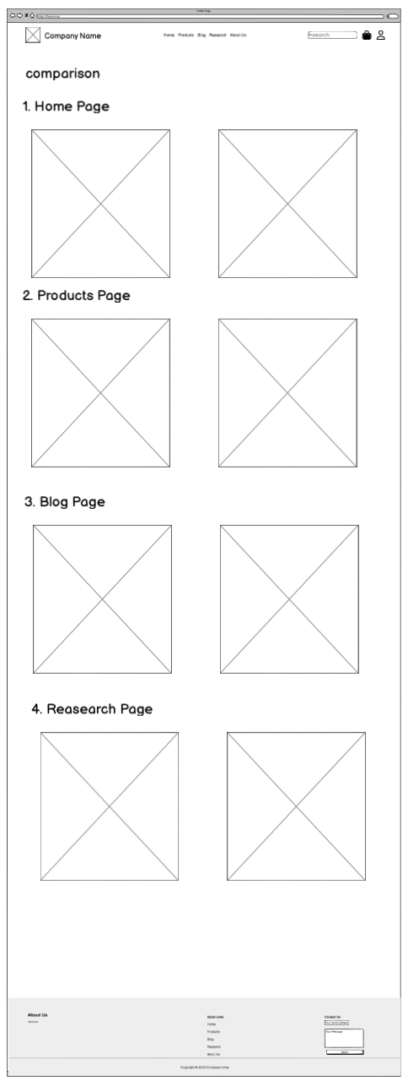

**Website:**

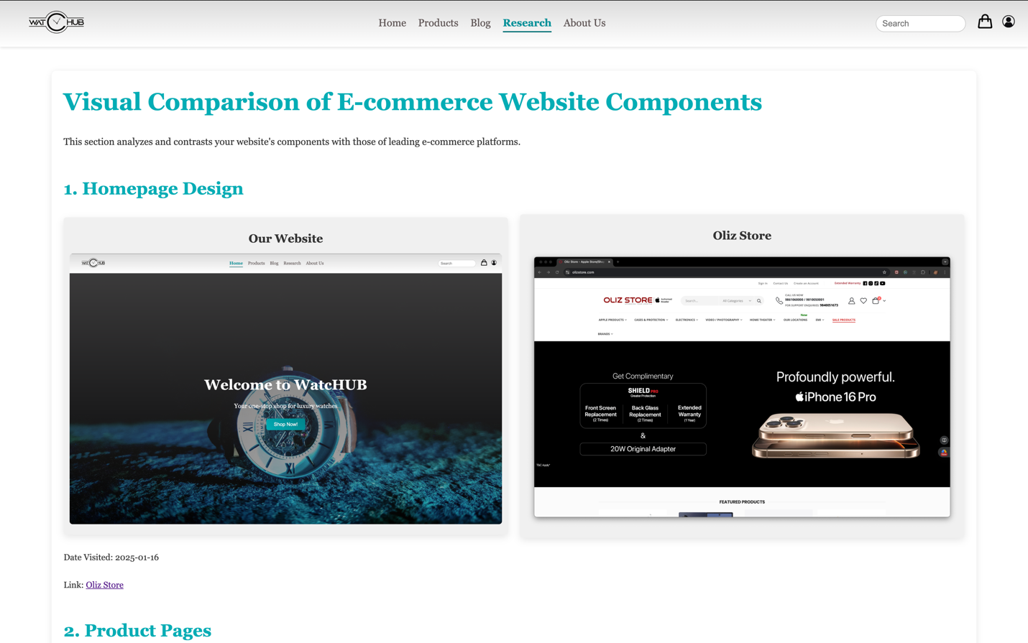

1. Cart Page: This is the section where the customers cart is shown.

**Wireframe:**

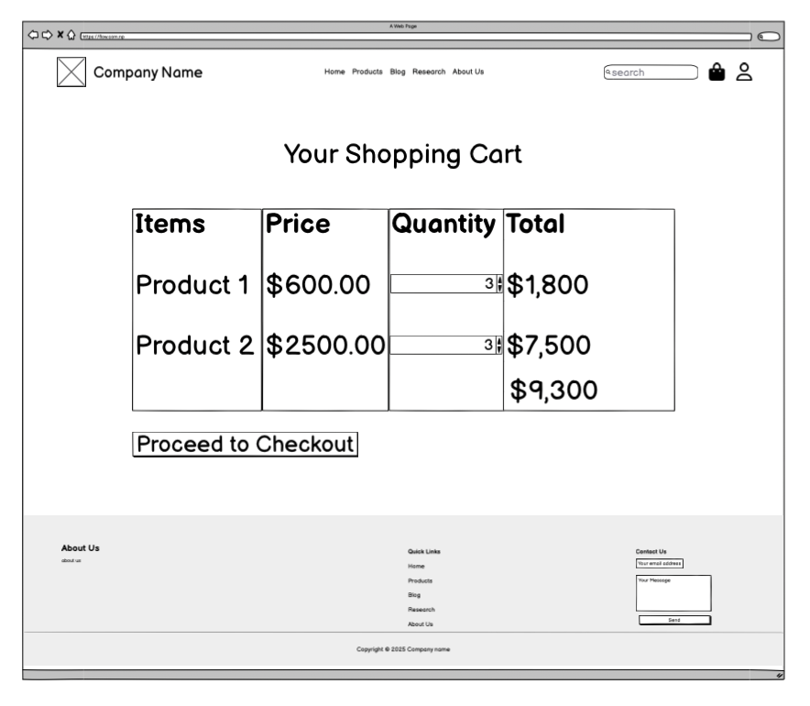

**Website:**

1. User Profile Page: This is the page where the customer’s account details are shown.

**Wireframe:**

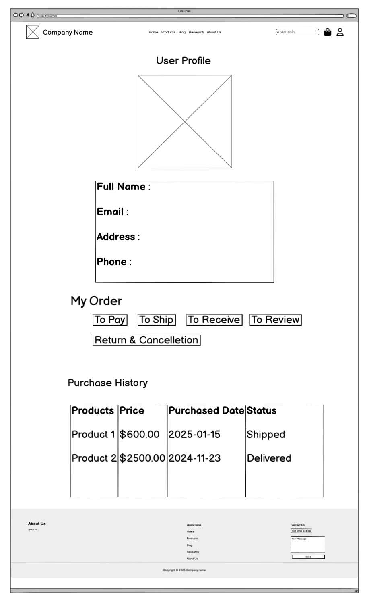

**Website:**

1. Detailed Blog Page: This is the page where the full blog is shown so the reader can read freely.

**Wireframe:**

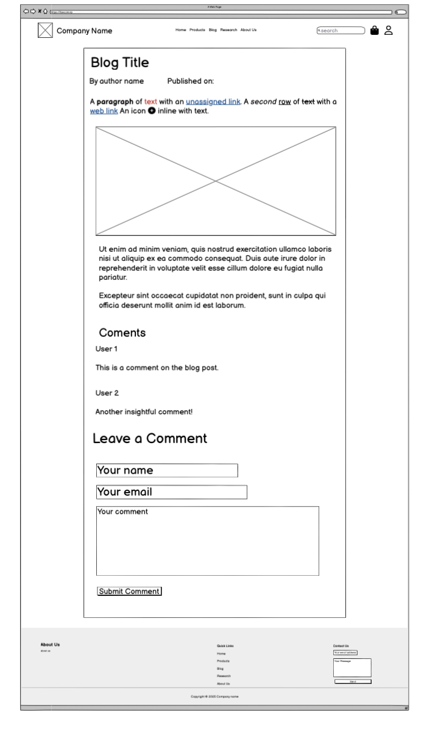

**Website:**

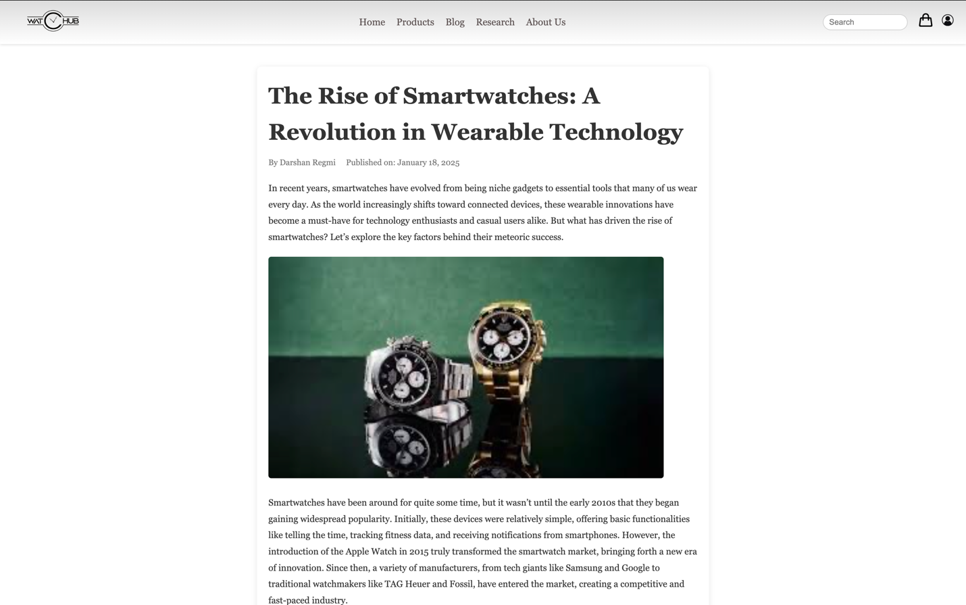

1. Detailed Product Page: This is the page where the product details are show for the customer to examine and view.

**Wireframe:**

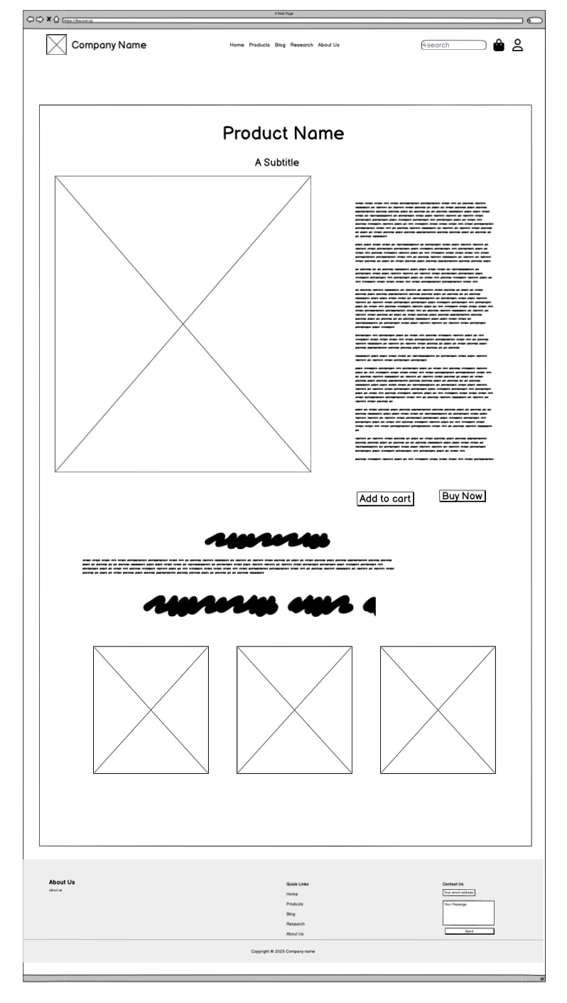

**Website:**

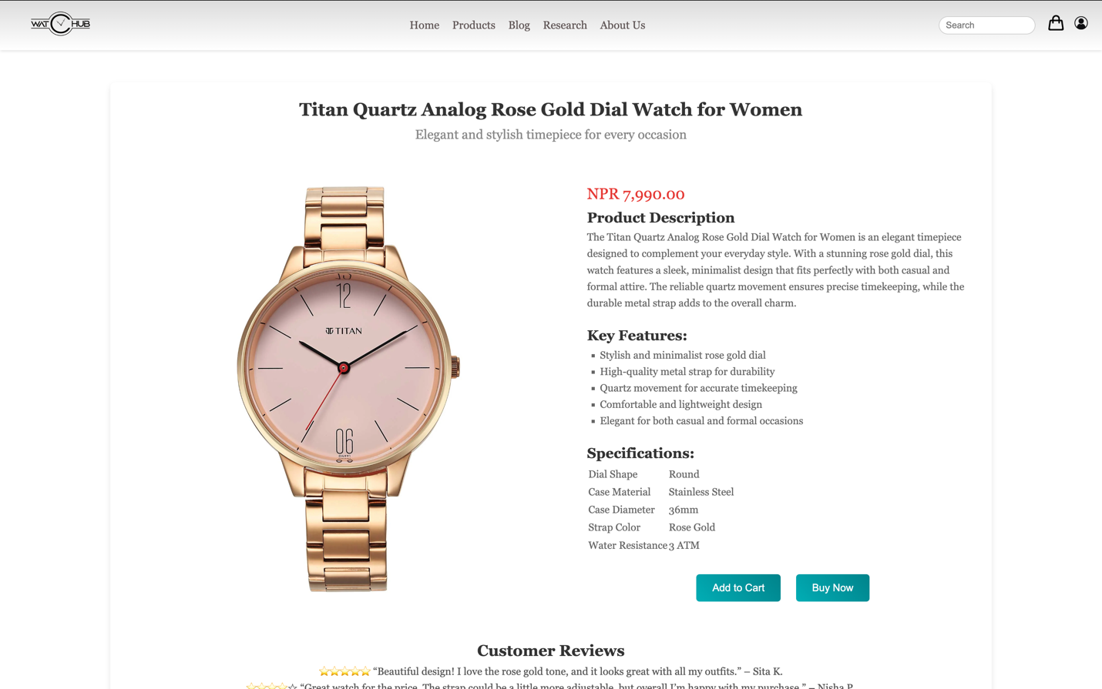

# Conclusion

It was a journey of insight into the development of our e-commerce platform since a lot was learnt with regards to various technologies which were use, along with some of the problems that were faced. This paper thus summarizes what was used, what was learned, and what hitches were faced, with the way they were surpassed.

## What we used?

The major components which were use for this project include:

* HTML gives structure to the content, laying it out.
* CSS for the styling of the platform to become responsive, hence good in viewing by the user.
* Visual Studio Code: Writing/editing our code using this as an IDE.
* GitHub: used for version control, sharing of our code, and collaboration between all team members.
* Google Chrome: Testing website functionality and viewing.
* Balsamiq Wireframes: Preliminary wireframing and planning of layout.
* Instagram: Team communication and updates.

## What we learned?

We gained so many experiences and knowledge during development, such as follow:

* Frontend Development: Knowledge improvement on HTML and CSS, such as making a structured, user-friendly platform with an appealing design.
* Collaboration and Version Control: learn how to use GitHub to work as a group to share and manage iterations of our code.
* Responsive Design: Different ways were learnt on how to make our website responsive to get it working on all devices and different screen sizes.

## Problems we faced.

We came across several problems while working on this project, including:

* Consistency in design will make the website look/feel great, considering screen sizes and different devices.
* The Layouts were Complex: Dynamic layout was required that could load several product listings, images, and other interactive elements on it.
* Browser Compatibility: This should work well in Chrome, Firefox, Safari, and so on.
* Team Coordination: Ensuring clarity in communication and proper work distribution within a team, many times we were working on partial parts of this project.

## How we solved the problem?

Approaches used in the handling of these challenges that arose including the following:

* Design Consistency: These consist of design consistency techniques using CSS Grid and Flexbox, which can position flexibly at varying screen sizes, thus easily changing over media queries.
* Complex Layout: Iterative testing has been conducted to make transitions smooth between sections on the platform.
* Browser Compatibility: Checked in browser, included all vendor prefixes along with other fixes in CSS for better handling to avoid browser compatibility issues.
* Coordination with Team: As the frequency of meetings over Instagram was smooth, code collaborations were smoothly executed on GitHub, hence being able to keep track of every contribution for later merging these contributions effectively.

## How the project could be better?

Core functionality and design goals have been accomplished for the e-commerce platform, but there's room for improvement in these places:

* Improved User Experience: Advanced product search, filter, sorting, and intuitiveness in buying a product. • Performance Optimization: Image compression, usage of lazy loading, and minification of CSS and JS files for reducing the site load.
* Backend Integration: Integration of a backend system would let this project work as a fully functional e-commerce website, where user information is stored, orders can be tracked, and systems for payment can be integrated.
* Accessibility: Accessibility can be further enhanced to meet the standards of WCAG, hence making it accessible for people with disabilities by the inclusion of better keyboard navigation and screen reader support.

# Appendix

## HTML:

### Home Page (index.html):

<!DOCTYPE html>

<html lang="en">

<head>

<meta charset="UTF-8">

<meta name="viewport" content="width=device-width, initial-scale=1.0">

<title>WatcHUB</title>

<link rel="stylesheet" href="/assets/css/styles.css">

<style>

/* Hero Section */

.hero {

display: flex;

flex-direction: column;

justify-content: center;

align-items: center;

height: 95vh;

background: url('/assets/img/banners/homeBanner.jpg') no-repeat center center;

background-size: cover;

position: relative;

color: #fff;

text-align: right;

}

.hero::before {

content: "";

position: absolute;

top: 0;

left: 0;

right: 0;

bottom: 0;

background: linear-gradient(to bottom, rgba(85, 83, 83, 0.7), rgba(0, 0, 0, 0.3));

}

.hero h1 {

font-size: 3.5rem;

z-index: 2;

margin-bottom: 20px;

}

.hero p {

font-size: 1.5rem;

z-index: 2;

margin-bottom: 30px;

}

.hero button {

padding: 12px 30px;

font-size: 1.2rem;

background: linear-gradient(45deg, #00ADB5, #00838a);

color: #fff;

border: none;

border-radius: 8px;

cursor: pointer;

z-index: 2;

transition: background 0.3s ease, transform 0.3s ease;

}

.hero button:hover {

background: linear-gradient(45deg, #00838a, #036065);

transform: scale(1.05);

}

/* Featured Products Section */

.featured-products {

background: linear-gradient(to bottom, #f9f9f9, #e9e9e9);

padding: 40px 20px;

text-align: center;

}

.section-header {

display: flex;

justify-content: space-around;

align-items: center;

width: 100%;

margin-bottom: 20px;

padding: 0 10px;

}

.section-header h2 {

font-size: 28px;

color: #333;

margin: 0;

flex: 1;

}

.view-all-link {

text-decoration: none;

font-size: 16px;

color: #00ADB5;

font-weight: bold;

transition: color 0.3s ease;

}

.view-all-link:hover {

color: #00838a;

}

.products-container {

display: flex;

justify-content: center;

align-items: center;

gap: 20px;

flex-wrap: wrap;

max-width: 1200px;

margin: 0 auto;

}

/* Product Card Styles */

.product-card {

background-color: #fff;

border: 1px solid #ddd;

border-radius: 12px;

width: 280px;

text-align: center;

padding: 20px;

box-shadow: 0 4px 12px rgba(0, 0, 0, 0.1);

transition: transform 0.3s ease, box-shadow 0.3s ease;

overflow: hidden;

}

.product-card:hover {

transform: translateY(-8px);

box-shadow: 0 10px 20px rgba(0, 0, 0, 0.2);

}

.product-card img {

width: 100%;

border-radius: 10px;

margin-bottom: 15px;

transition: transform 0.3s ease;

}

.product-card img:hover {

transform: scale(1.05);

}

.product-card h3 {

font-size: 20px;

color: #333;

margin-bottom: 10px;

}

.product-price {

font-size: 18px;

color: #666;

margin-bottom: 15px;

}

.buy-now-btn {

display: inline-block;

text-decoration: none;

background: linear-gradient(45deg, #00ADB5, #00838a);

color: #fff;

padding: 10px 20px;

border-radius: 5px;

font-size: 14px;

font-weight: bold;

transition: background 0.3s ease, transform 0.3s ease;

}

.buy-now-btn:hover {

background: linear-gradient(45deg, #00838a, #036065);

transform: scale(1.05);

}

/* Recent Blogs Section */

.recent-blogs {

background: linear-gradient(to bottom, #fafafa, #eaeaea);

padding: 40px 20px;

text-align: center;

}

.recent-blogs h2 {

font-size: 28px;

color: #333;

margin-bottom: 20px;

}

.blogs-container {

display: flex;

justify-content: center;

gap: 20px;

flex-wrap: wrap;

max-width: 1200px;

margin: 0 auto;

}

/* Blog Card Styles */

.blog-card {

background-color: #fff;

border: 1px solid #ddd;

border-radius: 12px;

width: 100%;

display: flex;

padding: 20px;

box-shadow: 0 4px 12px rgba(0, 0, 0, 0.1);

transition: transform 0.3s ease, box-shadow 0.3s ease;

align-items: center;

}

.blog-card:hover {

transform: translateY(-5px);

box-shadow: 0 10px 20px rgba(0, 0, 0, 0.2);

}

.blog-card img {

width: 600px;

height: 300px;

object-fit: cover;

border-radius: 10px;

margin-right: 20px;

}

.blog-card h3 {

font-size: 22px;

color: #333;

margin-bottom: 15px;

text-align: left;

}

.blog-card p {

font-size: 14px;

color: #666;

margin-bottom: 15px;

text-align: left;

}

/* Read More Button */

.read-more-btn {

display: inline-block;

margin-top: 20px;

text-decoration: none;

background: linear-gradient(45deg, #00ADB5, #00838a);

color: #fff;

padding: 0.75rem 1.5rem;

border-radius: 8px;

font-size: 1rem;

font-weight: 600;

transition: background 0.3s ease, transform 0.3s ease;

}

.read-more-btn:hover {

background: linear-gradient(45deg, #00838a, #036065);

transform: scale(1.05);

}

.read-more-btn:active {

transform: translateY(1px);

}

/* Customer Testimonial Section */

.testimonials-section {

padding: 40px;

background-color: #f9f9f9;

text-align: center;

}

.testimonials-section h2 {

font-size: 2rem;

margin-bottom: 20px;

}

.testimonial-container {

display: flex;

justify-content: center;

gap: 20px;

}

.testimonial {

background-color: #fff;

padding: 20px;

width: 300px;

border-radius: 8px;

box-shadow: 0 4px 8px rgba(0, 0, 0, 0.1);

transition: transform 0.3s ease, box-shadow 0.3s ease;

}

.testimonial p {

font-style: italic;

font-size: 1.1rem;

color: #555;

}

.customer-name {

font-weight: bold;

margin-top: 10px;

display: block;

}

.customer-location {

color: #888;

font-size: 0.9rem;

}

.testimonial:hover {

transform: translateY(-5px);

box-shadow: 0 10px 20px rgba(0, 0, 0, 0.2);

}

/* Why Us Section */

.why-us-section {

padding: 40px;

background-color: #fff;

text-align: center;

}

.why-us-section h2 {

font-size: 2rem;

margin-bottom: 20px;

}

.benefits {

display: grid;

grid-template-columns: 1fr 1fr 1fr 1fr;

gap: 30px;

justify-items: center;

}

.benefit {

background-color: #f4f4f4;

padding: 20px;

width: 250px;

border-radius: 8px;

box-shadow: 0 4px 8px rgba(0, 0, 0, 0.1);

transition: transform 0.3s ease, box-shadow 0.3s ease;

}

.benefit h3 {

font-size: 1.3rem;

color: #333;

margin-bottom: 10px;

}

.benefit p {

color: #555;

font-size: 1rem;

}

.benefit:hover {

transform: translateY(-5px);

box-shadow: 0 10px 20px rgba(0, 0, 0, 0.2);

}

/* responsive design */

@media (max-width: 1200px) {

.hero h1 {

font-size: 2.8rem;

}

.hero p {

font-size: 1.3rem;

}

.featured-products .section-header {

flex-direction: column;

align-items: center;

}

.products-container {

flex-direction: column;

align-items: center;

}

.product-card {

width: 90%;

}

.recent-blogs .blogs-container {

flex-direction: column;

align-items: center;

}

.blog-card {

width: 90%;

margin-bottom: 20px;

}

.testimonial-container {

flex-direction: column;

align-items: center;

}

.testimonial {

width: 80%;

}

}

@media (max-width: 768px) {

.hero h1 {

font-size: 2.2rem;

}

.hero p {

font-size: 1.1rem;

}

.hero button {

padding: 10px 20px;

font-size: 1rem;

}

.section-header h2 {

font-size: 24px;

}

.product-card {

width: 100%;

}

.blog-card img {

width: 100%;

height: auto;

}

.blog-card {

flex-direction: column;

align-items: center;

}

.testimonial {

width: 100%;

}

}

@media (max-width: 480px) {

.hero h1 {

font-size: 1.8rem;

}

.hero p {

font-size: 1rem;

}

.hero button {

padding: 8px 16px;

font-size: 0.9rem;

}

.section-header h2 {

font-size: 20px;

}

.product-card {

width: 100%;

margin-bottom: 20px;

}

.blog-card img {

width: 100%;

height: auto;

}

.blog-card {

flex-direction: column;

align-items: center;

}

.testimonial {

width: 100%;

margin-bottom: 15px;

}

}

@media (max-width: 1024px) {

.why-us-section h2 {

font-size: 1.8rem;

}

.benefits {

grid-template-columns: 1fr 1fr 1fr;

}

.benefit {

width: 90%;

}

}

@media (max-width: 768px) {

.why-us-section h2 {

font-size: 1.6rem;

}

.benefits {

grid-template-columns: 1fr 1fr;

}

.benefit {

width: 90%;

}

}

@media (max-width: 480px) {

.why-us-section {

padding: 20px;

}

.why-us-section h2 {

font-size: 1.4rem;

}

.benefits {

grid-template-columns: 1fr;

}

.benefit {

width: 100%;

}

}

</style>

</head>

<body>

<header class="header">

<div class="logo">

<a href="index.html"><img src="/assets/img/logo.png" alt="Company Logo"></a>

</div>

<nav class="nav-links">

<a href="index.html" class="active">Home</a>

<a href="/pages/products.html">Products</a>

<a href="/pages/blog.html">Blog</a>

<a href="/pages/research.html">Research</a>

<a href="/pages/about.html">About Us</a>

</nav>

<div class="header-tools">

<div class="search-bar">

<input type="text" placeholder="Search">

</div>

<div class="icons">

<a href="/pages/cart.html">

<img src="/assets/img/icons/cart.png" alt="Cart Icon" class="icon">

</a>

<a href="/pages/profile.html">

<img src="/assets/img/icons/user.png" alt="User Icon" class="icon">

</a>

</div>

</div>

</header>

<main>

<!-- Hero Section -->

<section class="hero">

<h1>Welcome to WatcHUB</h1>

<p>Your one-stop shop for luxury watches</p>

<button onclick="window.location.href='/pages/products.html';">Shop Now!</button>

</section>

<!-- Featured Products Section -->

<section class="featured-products">

<div class="container">

<div class="section-header">

<h2>Featured Products</h2>

<a href="/pages/products.html" class="view-all-link">View All Products</a>

</div>

<div class="products-container">

<div class="product-card">

<img src="/assets/img/products/product24.jpg" alt="Product 1">

<h3>Tudor Genene</h3>

<p class="product-price">$11,449</p>

<a href="#" class="buy-now-btn">Buy Now</a>

</div><div class="product-card">

<img src="/assets/img/products/product16.jpg" alt="Product 2">

<h3>Dillo SV2</h3>

<p class="product-price">$1,000,000</p>

<a href="#" class="buy-now-btn">Buy Now</a>

</div>

<div class="product-card">

<img src="/assets/img/products/product29.jpg" alt="Product 3">

<h3>Samaya Protal 245t</h3>

<p class="product-price">$2,995</p>

<a href="#" class="buy-now-btn">Buy Now</a>

</div>

</div>

</div>

</section>

<!-- Recent Blogs Section -->

<section class="recent-blogs">

<div class="container">

<h2>Recent Blogs</h2>

<div class="blogs-container">

<div class="blog-card">

<img src="/assets/img/blog/blogBanner/blogBanner1.jpg" alt="Blog 1">

<div class="blog-text">

<h3>The Rise of Smartwatches: A Revolution in Wearable Technology</h3>

<p>In recent years, smartwatches have evolved from being niche gadgets to essential tools that many of us wear every day. As the world increasingly shifts toward connected devices, these wearable innovations have become a must-have for technology enthusiasts and casual users alike. But what has driven the rise of smartwatches? Let’s explore the key factors behind their meteoric success.<br><a href="/pages/blogPages/blog1.html" class="read-more-btn"> Read More</a></p>

</div>

</div>

<div class="blog-card" style="flex-direction: row-reverse;">

<img src="/assets/img/blog/blogBanner/blogBanner2.jpg" alt="Blog 1">

<div class="blog-text">

<h3>The Cutting-Edge Technologies Revolutionizing the Watch Industry</h3>

<p>Watches have come a long way from being mere timekeepers to becoming sophisticated devices with a multitude of features. In the age of wearable technology, watches have evolved into powerful gadgets that not only tell time but also improve our lifestyle, enhance fitness, and even monitor our health. In this blog, we’ll explore the innovative technologies that are shaping the future of watches and why they are becoming essential accessories for everyone.<br><a href="/pages/blogPages/blog2.html" class="read-more-btn"> Read More</a></p>

</div>

</div>

</div>

</div>

</section>

<!-- Customer Testimonial Section -->

<section id="testimonials" class="testimonials-section">

<h2>What Our Customers Say</h2>

<div class="testimonial-container">

<div class="testimonial">

<p>"This is the best watch store I've ever shopped at! The selection is amazing and the customer service is top-notch."</p>

<span class="customer-name">John Doe</span>

<span class="customer-location">New York, USA</span>

</div>

<div class="testimonial">

<p>"I bought a luxury watch as a gift, and it arrived beautifully packaged. Truly an exceptional experience!"</p>

<span class="customer-name">Jane Smith</span>

<span class="customer-location">London, UK</span>

</div>

<div class="testimonial">

<p>"The quality of their products is unmatched. I'm a loyal customer now!"</p>

<span class="customer-name">Tom Brown</span>

<span class="customer-location">Sydney, Australia</span>

</div>

</div>

</section>

<!-- Why Us Section -->

<section class="why-us-section">

<h2>Why Choose Us?</h2>

<div class="benefits">

<div class="benefit">

<h3>Quality</h3>

<p>We offer only the highest quality watches from top brands.</p>

</div>

<div class="benefit">

<h3>Affordability</h3>

<p>Competitive prices for luxury watches.</p>

</div>

<div class="benefit">

<h3>Fast Delivery</h3>

<p>Fast and reliable shipping to your doorstep.</p>

</div>

<div class="benefit">

<h3>Customer Service</h3>

<p>Our team is here to assist you with any inquiries.</p>

</div>

</div>

</section>

</main>

<footer class="footer">

<div class="footer-content">

<div class="footer-section about">

<h1>About Us</h1>

<p>At WatcHUB, we offer a curated selection of quality timepieces for every occasion. Our goal is to provide exceptional products and service, helping you find the perfect watch for your style.</p>

</div>

<div class="footer-section links">

<h1>Quick Links</h1>

<ul>

<a href="index.html"><li>Home</li></a>

<a href="/pages/products.html"><li>Products</li></a>

<a href="/pages/blog.html"><li>Blog</li></a>

<a href="/pages/research.html"><li>Research</li></a>

<a href="/pages/about.html"><li>About Us</li></a>

</ul>

</div>

<div class="footer-section contact">

<h1>Contact Us</h1>

<form>

<input type="email" name="email" class="text-input contact-input" placeholder="Your email address...">

<textarea rows="4" name="message" class="text-input contact-input" placeholder="Your message..."></textarea>

<button type="submit" class="btn btn-big contact-btn">Send</button>

</form>

</div>

</div>

<div class="footer-bottom">

Copyright &copy; 2025 Watch Store

</div>

</footer>

</body>

</html>

### Product Page (products.html):

<!DOCTYPE html>

<html lang="en">

<head>

<meta charset="UTF-8">

<meta name="viewport" content="width=device-width, initial-scale=1.0">

<title>WatchHub - Products</title>

<link rel="stylesheet" href="/assets/css/styles.css">

<style>

/* Category Selector Styling */

.category-selector {

background-color: #fff;

padding: 15px 0;

border-bottom: 1px solid #ddd;

}

.category-selector ul {

list-style: none;

margin: 0;

padding: 0;

display: flex;

justify-content: center;

gap: 30px;

}

.category-selector li {

position: relative;

font-size: 16px;

font-weight: 500;

}

.category-selector a {

text-decoration: none;

color: #333;

padding: 10px 15px;

display: block;

transition: all 0.3s ease;

}

.category-selector a:hover {

background: linear-gradient(45deg, #00838a, #036065);

color: #fff;

border-radius: 4px;

}

/* Dropdown Menu Styling */

.dropdown:hover .dropdown-menu {

display: block;

opacity: 1;

visibility: visible;

}

.dropdown-menu {

display: none;

position: absolute;

top: 100%;

left: 0;

background-color: #fff;

border: 1px solid #ddd;

box-shadow: 0 4px 6px rgba(0, 0, 0, 0.1);

list-style: none;

padding: 10px 0;

min-width: 200px;

z-index: 1000;

opacity: 0;

visibility: hidden;

transition: opacity 0.5s ease, visibility 0s 0.3s;

}

.dropdown-menu li {

padding: 8px 20px;

}

.dropdown-menu li a {

color: #333;

font-weight: normal;

}

.dropdown-menu li a:hover {

color: #ffffff;

background: linear-gradient(45deg, #00838a, #036065);

}

/* Submenu (Second Level) */

.dropdown-menu .dropdown:hover .dropdown-menu {

display: block;

left: 100%;

top: 0;

}

/* Product Section Styling */

.products {

background: linear-gradient(to bottom, #f9f9f9, #e9e9e9);

padding: 40px 20px;

text-align: center;

}

.products-container {

display: flex;

justify-content: space-evenly;

align-items: center;

flex-wrap: wrap;

max-width: 1200px;

margin: 0 auto;

}

/* Product Card Styles */

.product-card {

background-color: #fff;

border: 1px solid #ddd;

border-radius: 12px;

width: calc(20% - 50px);

text-align: center;

padding: 20px;

box-shadow: 0 4px 12px rgba(0, 0, 0, 0.1);

transition: transform 0.3s ease, box-shadow 0.3s ease;

overflow: hidden;

margin-bottom: 20px;

}

.product-card:hover {

transform: translateY(-8px);

box-shadow: 0 10px 20px rgba(0, 0, 0, 0.2);

}

.product-card img {

width: 100%;

border-radius: 10px;

margin-bottom: 15px;

transition: transform 0.3s ease;

}

.product-card img:hover {

transform: scale(1.05);

}

.product-card h3 {

font-size: auto;

color: #333;

margin-bottom: 10px;

}

.product-price {

font-size: 18px;

color: #666;

margin-bottom: 15px;

}

.buy-now-btn {

display: inline-block;

text-decoration: none;

background: linear-gradient(45deg, #00ADB5, #00838a);

color: #fff;

padding: 10px 20px;

border-radius: 5px;

font-size: 14px;

font-weight: bold;

transition: background 0.3s ease, transform 0.3s ease;

}

.buy-now-btn:hover {

background: linear-gradient(45deg, #00838a, #036065);

transform: translateY(-3px);

}

/*Responsive Styles*/

@media (max-width: 1024px) {

.category-selector ul {

flex-direction: column;

gap: 20px;

}

.category-selector li {

text-align: center;

}

.products-container {

justify-content: space-between;

}

.product-card {

width: calc(33.33% - 30px);

margin: 10px;

}

.dropdown-menu {

min-width: 150px;

}

}

@media (max-width: 768px) {

.category-selector ul {

flex-direction: column;

align-items: center;

gap: 15px;

}

.category-selector li {

font-size: 14px;

}

.category-selector a {

padding: 8px 15px;

}

.products-container {

justify-content: center;

}

.product-card {

width: 80%;

margin: 15px 0;

}

.product-card h3 {

font-size: 18px;

}

.product-price {

font-size: 16px;

}

.buy-now-btn {

font-size: 12px;

padding: 8px 15px;

}

.dropdown-menu {

min-width: 120px;

}

}

@media (max-width: 480px) {

.category-selector ul {

gap: 10px;

}

.category-selector a {

padding: 8px;

font-size: 14px;

}

.product-card {

width: 90%;

margin: 15px 0;

}

.buy-now-btn {

font-size: 11px;

padding: 8px 12px;

}

}

</style>

</head>

<body>

<header class="header">

<!-- Logo and Navigation -->

<div class="logo">

<a href="../index.html"><img src="/assets/img/logo.png" alt="Company Logo"></a>

</div>

<nav class="nav-links">

<a href="../index.html">Home</a>

<a href="products.html" class="active">Products</a>

<a href="blog.html">Blog</a>

<a href="research.html">Research</a>

<a href="about.html">About Us</a>

</nav>

<div class="header-tools">

<div class="search-bar">

<input type="text" placeholder="Search">

</div>

<div class="icons">

<a href="/pages/cart.html">

<img src="/assets/img/icons/cart.png" alt="Cart Icon" class="icon">

</a>

<a href="/pages/profile.html">

<img src="/assets/img/icons/user.png" alt="User Icon" class="icon">

</a>

</div>

</div>

</header>

<!-- Category Selector -->

<nav class="category-selector">

<ul>

<li class="dropdown">

<a href="#mens-watches">Men's Watches</a>

<ul class="dropdown-menu">

<li><a href="#analog-mens">Analog Watches</a></li>

<li><a href="#digital-mens">Digital Watches</a></li>

<li><a href="#smart-mens">Smart Watches</a></li>

<li><a href="#fitness-mens">Fitness Watches</a></li>

<li><a href="#luxury-sports-mens">Luxury Sports Watches</a></li>

<li><a href="#vintage-mens">Vintage Watches</a></li>

</ul>

</li>

<li class="dropdown">

<a href="#womens-watches">Women's Watches</a>

<ul class="dropdown-menu">

<li><a href="#analog-womens">Analog Watches</a></li>

<li><a href="#digital-womens">Digital Watches</a></li>

<li><a href="#smart-womens">Smart Watches</a></li>

<li><a href="#fitness-womens">Fitness Watches</a></li>

<li><a href="#luxury-sports-womens">Luxury Sports Watches</a></li>

<li><a href="#vintage-womens">Vintage Watches</a></li>

</ul>

</li>

<li class="dropdown">

<a href="#kids-watches">Kids' Watches</a>

<ul class="dropdown-menu">

<li><a href="#analog-kids">Analog Watches</a></li>

<li><a href="#digital-kids">Digital Watches</a></li>

</ul>

</li>

<li class="dropdown">

<a href="#luxury-watches">Luxury Watches</a>

<ul class="dropdown-menu">

<li><a href="#designer">Designer Watches</a></li>

<li><a href="#exclusive">Exclusive Brands</a></li>

<li><a href="#luxury-mens">Luxury Men's Watches</a></li>

<li><a href="#luxury-womens">Luxury Women's Watches</a></li>

</ul>

</li>

</ul>

</nav>

<!-- Main Content -->

<main>

<section class="products">

<div class="container">

<div class="products-container">

<div class="product-card">

<img src="/assets/img/products/product1.jpg" alt="Titan Quartz Analog Rose Gold Dial Watch for Women">

<h3 style="font-size: small;">Titan Quartz Analog Rose Gold Dial Watch for Women</h3>

<p class="product-price">NPR 7,990.00</p>

<a href="productPages/productPage1.html" class="buy-now-btn">Buy Now</a>

</div>

<div class="product-card">

<img src="/assets/img/products/product2.jpg" alt="Ultima Watch Circle">

<h3>Ultima Watch Circle</h3>

<p class="product-price">NPR 3,899.00</p>

<a href="productPages/productPage2.html" class="buy-now-btn">Buy Now</a>

</div>

<div class="product-card">

<img src="/assets/img/products/product3.jpg" alt="Brihaspari Black">

<h3>Brihaspari Black</h3>

<p class="product-price">NPR 23,999.00</p>

<a href="productPages/productPage3.html" class="buy-now-btn">Buy Now</a>

</div>

<div class="product-card">

<img src="/assets/img/products/product4.jpg" alt="Rolex Datejust 41">

<h3>Rolex Datejust 41</h3>

<p class="product-price" style="font-size:15px">NPR 6,500,000.00</p>

<a href="productPages/productPage4.html" class="buy-now-btn">Buy Now</a>

</div>

<div class="product-card">

<img src="/assets/img/products/product5.jpg" alt="Breguet Type XX">

<h3>Breguet Type XX</h3>

<p class="product-price">$14,449.00</p>

<a href="productPages/productPage5.html" class="buy-now-btn">Buy Now</a>

</div>

<div class="product-card">

<img src="/assets/img/products/product6.jpg" alt="Casio G-Shock Mudmaster">

<h3>Casio G-Shock Mudmaster</h3>

<p class="product-price">NPR 19,999.00</p>

<a href="productPages/productPage6.html" class="buy-now-btn">Buy Now</a>

</div>

<div class="product-card">

<img src="/assets/img/products/product7.jpg" alt="Apple Watch Series 9">

<h3>Apple Watch Series 9</h3>

<p class="product-price">NPR 79,999.00</p>

<a href="#" class="buy-now-btn">Buy Now</a>

</div>

<div class="product-card">

<img src="/assets/img/products/product8.jpg" alt="Seiko 5 Sports">

<h3 style="font-size: 21px;">Seiko 5 Sports</h3>

<p class="product-price">NPR 15,499.00</p>

<a href="#" class="buy-now-btn">Buy Now</a>

</div>

<div class="product-card">

<img src="/assets/img/products/product9.jpg" alt="Omega Speedmaster Professional">

<h3 style="font-size: 14.08px;">Omega Speedmaster Professional</h3>

<p class="product-price">$10,000.00</p>

<a href="#" class="buy-now-btn">Buy Now</a>

</div>

<div class="product-card">

<img src="/assets/img/products/product10.jpg" alt="Fossil Gen 6 Smartwatch">

<h3>Fossil Gen 6 Smartwatch</h3>

<p class="product-price">NPR 25,999.00</p>

<a href="#" class="buy-now-btn">Buy Now</a>

</div>

<div class="product-card">

<img src="/assets/img/products/product11.jpg" alt="Tag Heuer Carrera">

<h3>Tag Heuer Carrera</h3>

<p class="product-price">$16,000.00</p>

<a href="#" class="buy-now-btn">Buy Now</a>

</div>

<div class="product-card">

<img src="/assets/img/products/product12.jpg" alt="Citizen Eco-Drive Promaster">

<h3 style="font-size: 17.207px;">Citizen Eco-Drive Promaster</h3>

<p class="product-price">NPR 18,499.00</p>

<a href="#" class="buy-now-btn">Buy Now</a>

</div>

<div class="product-card">

<img src="/assets/img/products/product13.jpg" alt="Samsung Galaxy Watch 6">

<h3>Samsung Galaxy Watch 6</h3>

<p class="product-price">NPR 42,999.00</p>

<a href="#" class="buy-now-btn">Buy Now</a>

</div>

<div class="product-card">

<img src="/assets/img/products/product14.jpg" alt="Hamilton Khaki Field Mechanical">

<h3>Hamilton Khaki Field Mechanical</h3>

<p class="product-price">NPR 29,999.00</p>

<a href="#" class="buy-now-btn">Buy Now</a>

</div>

<div class="product-card">

<img src="/assets/img/products/product15.jpg" alt="Longines Master Collection">

<h3>Longines Master Collection</h3>

<p class="product-price">$11,500.00</p>

<a href="#" class="buy-now-btn">Buy Now</a>

</div>

<div class="product-card">

<img src="/assets/img/products/product16.jpg" alt="Tissot Le Locle Automatic">

<h3 style="font-size: 20.4px;">Tissot Le Locle Automatic</h3>

<p class="product-price">NPR 32,990.00</p>

<a href="#" class="buy-now-btn">Buy Now</a>

</div>

<div class="product-card">

<img src="/assets/img/products/product17.jpg" alt="Hublot Classic Fusion">

<h3 style="font-size: 20.7px;">Hublot Classic Fusion</h3>

<p class="product-price">$17,800.00</p>

<a href="#" class="buy-now-btn">Buy Now</a>

</div>

<div class="product-card">

<img src="/assets/img/products/product18.jpg" alt="Audemars Piguet Royal Oak">

<h3>Audemars Piguet Royal Oak</h3>

<p class="product-price">$25,000.00</p>

<a href="#" class="buy-now-btn">Buy Now</a>

</div>

<div class="product-card">

<img src="/assets/img/products/product19.jpg" alt="Cartier Ballon Bleu">

<h3 style="font-size: 20.7px;">Cartier Ballon Bleu</h3>

<p class="product-price">$15,999.00</p>

<a href="#" class="buy-now-btn">Buy Now</a>

</div>

<div class="product-card">

<img src="/assets/img/products/product20.jpg" alt="Patek Philippe Nautilus">

<h3 style="font-size: 19.5px;">Patek Philippe Nautilus</h3>

<p class="product-price">$35,999.00</p>

<a href="#" class="buy-now-btn">Buy Now</a>

</div>

<div class="product-card">

<img src="/assets/img/products/product21.jpg" alt="Bulova Precisionist">

<h3>Bulova Precisionist</h3>

<p class="product-price">NPR 15,499.00</p>

<a href="#" class="buy-now-btn">Buy Now</a>

</div>

<div class="product-card">

<img src="/assets/img/products/product22.jpg" alt="Frederique Constant Slimline">

<h3 style="font-size: 100.20%;">Frederique Constant Slimline</h3>

<p class="product-price">NPR 28,999.00</p>

<a href="#" class="buy-now-btn">Buy Now</a>

</div>

<div class="product-card">

<img src="/assets/img/products/product23.jpg" alt="Timex Expedition Field Chronograph">

<h3 style="font-size: 12.4px;">Timex Expedition Field Chronograph</h3>

<p class="product-price">NPR 6,499.00</p>

<a href="#" class="buy-now-btn">Buy Now</a>

</div>

<div class="product-card">

<img src="/assets/img/products/product24.jpg" alt="Michael Kors Lexington">

<h3>Michael Kors Lexington</h3>

<p class="product-price">NPR 18,999.00</p>

<a href="#" class="buy-now-btn">Buy Now</a>

</div>

<div class="product-card">

<img src="/assets/img/products/product25.jpg" alt="Grand Seiko Spring Drive">

<h3>Grand Seiko Spring Drive</h3>

<p class="product-price">$22,500.00</p>

<a href="#" class="buy-now-btn">Buy Now</a>

</div>

<div class="product-card">

<img src="/assets/img/products/product26.jpg" alt="Movado Museum Classic">

<h3 style="font-size: 15.4px;">Movado Museum Classic</h3>

<p class="product-price">NPR 24,499.00</p>

<a href="#" class="buy-now-btn">Buy Now</a>

</div>

<div class="product-card">

<img src="/assets/img/products/product27.jpg" alt="Rado True Square">

<h3>Rado True Square</h3>

<p class="product-price">$9,300.00</p>

<a href="#" class="buy-now-btn">Buy Now</a>

</div>

<div class="product-card">

<img src="/assets/img/products/product28.jpg" alt="Orient Bambino Version 5">

<h3 style="font-size: 15.4px;">Orient Bambino Version 5</h3>

<p class="product-price">NPR 13,499.00</p>

<a href="#" class="buy-now-btn">Buy Now</a>

</div>

<div class="product-card">

<img src="/assets/img/products/product29.jpg" alt="Diesel Mega Chief Chronograph">

<h3 style="font-size: 15.4px;">Diesel Mega Chief Chronograph</h3>

<p class="product-price">NPR 19,999.00</p>

<a href="#" class="buy-now-btn">Buy Now</a>

</div>

<div class="product-card">

<img src="/assets/img/products/product30.jpg" alt="Tommy Hilfiger Classic Blue">

<h3 style="font-size: 15.4px;">Tommy Hilfiger Classic Blue</h3>

<p class="product-price">NPR 14,999.00</p>

<a href="#" class="buy-now-btn">Buy Now</a>

</div>

</div>

</div>

</section>

</main>

<!-- Footer -->

<footer class="footer">

<div class="footer-content">

<div class="footer-section about">

<h1>About Us</h1>

<p>At WatcHUB, we offer a curated selection of quality timepieces for every occasion. Our goal is to provide exceptional products and service, helping you find the perfect watch for your style.</p>

</div>

<div class="footer-section links">

<h1>Quick Links</h1>

<ul>

<a href="index.html"><li>Home</li></a>

<a href="/pages/products.html"><li>Products</li></a>

<a href="/pages/blog.html"><li>Blog</li></a>

<a href="/pages/research.html"><li>Research</li></a>

<a href="/pages/about.html"><li>About Us</li></a>

</ul>

</div>

<div class="footer-section contact">

<h1>Contact Us</h1>

<form>

<input type="email" name="email" class="text-input contact-input" placeholder="Your email address...">

<textarea rows="4" name="message" class="text-input contact-input" placeholder="Your message..."></textarea>

<button type="submit" class="btn btn-big contact-btn">Send</button>

</form>

</div>

</div>

<div class="footer-bottom">

Copyright &copy; 2025 Watch Store

</div>

</footer>

</body>

</html>

### Blog Page (blog.html):

<!DOCTYPE html>

<html lang="en">

<head>

<meta charset="UTF-8">

<meta name="viewport" content="width=device-width, initial-scale=1.0">

<title>WatcHUB - Blog</title>

<link rel="stylesheet" href="/assets/css/styles.css">

<style>

/* Hero Section */

.hero {

background: url('../assets/img/banners/blog.jpg') no-repeat center center/cover;

color: white;

padding: 60px 20px;

text-align: center;

}

.hero h1 {

font-size: 2.5rem;

margin-bottom: 20px;

}

.hero p {

font-size: 1.2rem;

max-width: 600px;

margin: 0 auto;

margin-bottom: 20px;

color: #ffffff;

}

.hero button {

padding: 12px 30px;

font-size: 1.2rem;

background: linear-gradient(45deg, #00ADB5, #00838a);

color: #fff;

border: none;

border-radius: 8px;

cursor: pointer;

z-index: 2;

transition: background 0.3s ease, transform 0.3s ease;

}

.hero button:hover {

background: linear-gradient(45deg, #00838a, #036065);

transform: scale(1.05);

}

/* Recent Blogs Section */

.blogs {

background: linear-gradient(to bottom, #fafafa, #eaeaea);

padding: 40px 20px;

text-align: center;

}

.blogs h2 {

font-size: 28px;

color: #333;

margin-bottom: 20px;

}

.blogs-container {

display: flex;

justify-content: center;

gap: 20px;

flex-wrap: wrap;

max-width: 1200px;

margin: 0 auto;

}

/* Blog Card Styles */

.blog-card {

background-color: #fff;

border: 1px solid #ddd;

border-radius: 12px;

width: 100%;

display: flex;

padding: 20px;

box-shadow: 0 4px 12px rgba(0, 0, 0, 0.1);

transition: transform 0.3s ease, box-shadow 0.3s ease;

align-items: center;

}

.blog-card:hover {

transform: translateY(-5px);

box-shadow: 0 10px 20px rgba(0, 0, 0, 0.2);

}

.blog-card img {

width: 600px;

height: 300px;

object-fit: cover;

border-radius: 10px;

margin-right: 20px;

}

.blog-card h3 {

font-size: 22px;

color: #333;

margin-bottom: 15px;

text-align: left;

}

.blog-card p {

font-size: 14px;

color: #666;

margin-bottom: 15px;

text-align: left;

margin-right: 20px;

}

.blog-card a {

color: #00ADB5;

text-decoration: none;

font-weight: 600;

}

/* Responsive Styles */

@media (max-width: 768px) {

.hero h1 {

font-size: 2rem;

}

.hero p {

font-size: 1rem;

}

.hero button {

font-size: 1rem;

padding: 10px 20px;

}

}

@media (max-width: 768px) {

.blogs-container {

gap: 15px;

}

.blog-card {

text-align: center;

flex-direction: column;

}

.blog-card img {

margin: 0 auto 15px;

}

}

@media (max-width: 480px) {

.hero {

padding: 40px 15px;

}

.hero h1 {

font-size: 1.8rem;

}

.hero p {

font-size: 0.9rem;

}

.blogs h2 {

font-size: 22px;

}

.blog-card h3 {

font-size: 18px;

}

.blog-card p {

font-size: 12px;

}

}

</style>

</head>

<body>

<header class="header">

<!-- Logo and Navigation -->

<div class="logo">

<a href="../index.html"><img src="/assets/img/logo.png" alt="Company Logo"></a>

</div>

<nav class="nav-links">

<a href="../index.html">Home</a>

<a href="products.html">Products</a>

<a href="blog.html" class="active">Blog</a>

<a href="research.html">Research</a>

<a href="about.html">About Us</a>

</nav>

<div class="header-tools">

<div class="search-bar">

<input type="text" placeholder="Search">

</div>

<div class="icons">

<a href="/pages/cart.html">

<img src="/assets/img/icons/cart.png" alt="Cart Icon" class="icon">

</a>

<a href="/pages/profile.html">

<img src="/assets/img/icons/user.png" alt="User Icon" class="icon">

</a>

</div>

</div>

</header>

<!-- Hero Section -->

<section class="hero">

<h1>Welcome to WatcHUB Articles</h1>

<p>Here you can read our latest articles and blogs.</p>

<button>Read Articles</button>

</section>

<section class="blogs">

<div class="container">

<h2>Blogs</h2>

<div class="blogs-container">

<div class="blog-card">

<img src="/assets/img/blog/blogBanner/blogBanner1.jpg" alt="Blog 1">

<div class="blog-text">

<h3>The Rise of Smartwatches: A Revolution in Wearable Technology</h3>

<p>In recent years, smartwatches have evolved from being niche gadgets to essential tools that many of us wear every day. As the world increasingly shifts toward connected devices, these wearable innovations have become a must-have for technology enthusiasts and casual users alike. But what has driven the rise of smartwatches? Let’s explore the key factors behind their meteoric success.<br><a href="/pages/blogPages/blog1.html" class="read-more-btn"> Read More</a></p>

</div>

</div>

<div class="blog-card" style="flex-direction: row-reverse;">

<img src="/assets/img/blog/blogBanner/blogBanner2.jpg" alt="Blog 1">

<div class="blog-text">

<h3>The Cutting-Edge Technologies Revolutionizing the Watch Industry</h3>

<p>Watches have come a long way from being mere timekeepers to becoming sophisticated devices with a multitude of features. In the age of wearable technology, watches have evolved into powerful gadgets that not only tell time but also improve our lifestyle, enhance fitness, and even monitor our health. In this blog, we’ll explore the innovative technologies that are shaping the future of watches and why they are becoming essential accessories for everyone.<br><a href="/pages/blogPages/blog2.html" class="read-more-btn"> Read More</a></p>

</div>

</div>

<div class="blog-card">

<img src="/assets/img/blog/blogBanner/blogBanner3.jpg" alt="Blog 1">

<div class="blog-text">

<h3>The Positive Impact of Watches: More Than Just Timekeepers</h3>

<p>Watches have long been admired for their practicality and aesthetic appeal. While they started as simple tools to track time, their role in modern life has expanded far beyond that. Today, watches are more than just functional accessories—they have a positive impact on our daily lives, health, fashion, and even the environment. Let’s explore the many ways in which watches contribute to our well-being and success.<br><a href="/pages/blogPages/blog3.html" class="read-more-btn"> Read More</a></p>

</div>

</div>

<div class="blog-card" style="flex-direction: row-reverse;">

<img src="/assets/img/blog/blogBanner/blogBanner4.jpg" alt="Blog 1">

<div class="blog-text">

<h3>The Negative Impact of Watches: Beyond the Timekeeper</h3>

<p>Watches have long been admired for their functionality and fashion-forward appeal. However, as with any technology or accessory, there are certain negative impacts that come with their use. While they offer convenience and style, it’s essential to acknowledge the potential downsides of wearing and relying on watches. Let’s dive into the less-discussed consequences of our attachment to these timepieces.<br><a href="/pages/blogPages/blog4.html" class="read-more-btn"> Read More</a></p>

</div>

</div>

<div class="blog-card">

<img src="/assets/img/blog/blogBanner/blogBanner5.jpg" alt="Blog 1">

<div class="blog-text">

<h3>Leveraging Technology to Boost Watch Sales</h3>

<p>The watch industry is rapidly evolving, and the rise of technology offers immense opportunities to enhance the sales and marketing strategies for watch brands. From the introduction of smartwatches to e-commerce advancements and personalized marketing, technology is transforming the way watches are sold. Let’s explore how technology can be utilized to drive sales in the watch industry.<br><a href="/pages/blogPages/blog5.html" class="read-more-btn"> Read More</a></p>

</div>

</div>

</div>

</div>

</section>

<footer class="footer">

<div class="footer-content">

<div class="footer-section about">

<h1>About Us</h1>

<p>At WatcHUB, we offer a curated selection of quality timepieces for every occasion. Our goal is to provide exceptional products and service, helping you find the perfect watch for your style.</p>

</div>

<div class="footer-section links">

<h1>Quick Links</h1>

<ul>

<a href="#"><li>Home</li></a>

<a href="#"><li>Products</li></a>

<a href="#"><li>Blog</li></a>

<a href="#"><li>Research</li></a>

<a href="#"><li>About Us</li></a>

</ul>

</div>

<div class="footer-section contact">

<h1>Contact Us</h1>

<form action="#" method="post">

<input type="email" name="email" class="text-input contact-input" placeholder="Your email address...">

<textarea rows="4" name="message" class="text-input contact-input" placeholder="Your message..."></textarea>

<button type="submit" class="btn btn-big contact-btn">

<i class="fas fa-envelope"></i>

Send

</button>

</form>

</div>

</div>

<div class="footer-bottom">

Copyright &copy; 2025 Watch Store

</div>

</footer>

</body>

</html>

### Research Page (research.html):

<!DOCTYPE html>

<html lang="en">

<head>

<meta charset="UTF-8">

<meta name="viewport" content="width=device-width, initial-scale=1.0">

<title>WatcHUB - Research</title>

<link rel="stylesheet" href="/assets/css/styles.css">

<style>

/* Main Content */

.main-content {

max-width: 90%;

margin: 40px auto;

padding: 20px;

background: #fff;

border-radius: 8px;

box-shadow: 0 2px 10px rgba(0, 0, 0, 0.1);

}

h1, h2 {

color: #00ADB5;

margin-bottom: 20px;

}

h1 {

font-size: 2.5rem;

}

h2 {

font-size: 1.8rem;

}

p {

margin-bottom: 15px;

line-height: 1.8;

}

/* Visual Comparison Section */

.comparison-section {

margin-top: 40px;

}

.comparison-section p {

margin-top: 20px;

font-size: 0.9rem;

text-decoration: none;

}

.comparison-grid {

display: grid;

grid-template-columns: repeat(auto-fill, minmax(500px, 1fr));

gap: 20px;

justify-content: space-between;

align-items: center;

}

.comparison-item {

background: #f0f0f0;

border-radius: 5px;

padding: 10px;

text-align: center;

box-shadow: 0 4px 12px rgba(0, 0, 0, 0.1);

transition: transform 0.3s ease, box-shadow 0.3s ease;

overflow: hidden;

}

.comparison-item:hover {

transform: translateY(-8px);

box-shadow: 0 10px 20px rgba(0, 0, 0, 0.2);

}

.comparison-item img {

max-width: 100%;

border-radius: 5px;

align-items: center;

}

.comparison-item h3 {

margin: 10px 0;

font-size: 1.2rem;

}

/* Media Queries for Responsiveness */

@media (max-width: 768px) {

.main-content {

max-width: 95%;

padding: 15px;

}

h1 {

font-size: 2rem;

}

h2 {

font-size: 1.5rem;

}

p {

font-size: 0.95rem;

line-height: 1.6;

}

.comparison-grid {

grid-template-columns: repeat(auto-fill, minmax(250px, 1fr));

gap: 15px;

}

.comparison-item h3 {

font-size: 1rem;

}

.references ul li {

font-size: 0.95rem;

}

}

@media (max-width: 480px) {

.main-content {

margin: 20px auto;

padding: 10px;

}

h1 {

font-size: 1.8rem;

}

h2 {

font-size: 1.2rem;

}

p {

font-size: 0.85rem;

}

.comparison-grid {

grid-template-columns: 1fr;

gap: 10px;

}

.comparison-item {

padding: 8px;

}

.comparison-item h3 {

font-size: 0.9rem;

}

.references ul li {

font-size: 0.85rem;

}

}

</style>

</head>

<body>

<header class="header">

<div class="logo">

<a href="../index.html"><img src="/assets/img/logo.png" alt="Company Logo"></a>

</div>

<nav class="nav-links">

<a href="../index.html">Home</a>

<a href="products.html">Products</a>

<a href="blog.html">Blog</a>

<a href="research.html" class="active">Research</a>

<a href="about.html">About Us</a>

</nav>

<div class="header-tools">

<div class="search-bar">

<input type="text" placeholder="Search">

</div>

<div class="icons">

<a href="cart.html">

<img src="/assets/img/icons/cart.png" alt="Cart Icon" class="icon">

</a>

<a href="profile.html">

<img src="/assets/img/icons/user.png" alt="User Icon" class="icon">

</a>

</div>

</div>

</header>

<main>

<div class="main-content">

<h1>Visual Comparison of E-commerce Website Components</h1>

<p>This section analyzes and contrasts your website's components with those of leading e-commerce platforms.</p>

<div class="comparison-section">

<h2>1. Homepage Design</h2>

<div class="comparison-grid">

<div class="comparison-item">

<h3>Our Website</h3>

<img src="/assets/img/ourPage/homePage.jpg" alt="Our Homepage Screenshot">

</div>

<div class="comparison-item">

<h3>Oliz Store</h3>

<img src="/assets/img/reference/home.jpg" alt="Oliz Store Homepage Screenshot">

</div>

</div>

<p>Date Visited: 2025-01-16</p>

<p>Link: <a href="https://www.olizstore.com/">Oliz Store</a></p>

</div>

<div class="comparison-section">

<h2>2. Product Pages</h2>

<div class="comparison-grid" style="grid-template-columns: repeat(auto-fill, minmax(450px, 1fr));">

<div class="comparison-item">

<h3>Our Website</h3>

<img src="/assets/img/ourPage/productPage.jpg" alt="Our Product Page Screenshot">

</div>

<div class="comparison-item">

<h3>Oliz Store</h3>

<img src="/assets/img/reference/product.jpg" alt="Oliz Store Product Page Screenshot">

</div>

<div class="comparison-item">

<h3>Daraz</h3>

<img src="/assets/img/reference/product1.jpg" alt="Daraz Product Page Screenshot">

</div>

</div>

<p>Date Visited: 2025-01-16</p>

<p>Link: <a href="https://www.olizstore.com/">Oliz Store</a></p>

<p>Link: <a href="https://www.daraz.com.np/">Daraz</a></p>

</div>

<div class="comparison-section">

<h2>3. Blog Pages</h2>

<div class="comparison-grid">

<div class="comparison-item">

<h3>Our Website</h3>

<img src="/assets/img/ourPage/blogPage.jpg" alt="Our Product Page Screenshot">

</div>

<div class="comparison-item">

<h3>Medium</h3>

<img src="/assets/img/reference/blog.jpg" alt="Medium Blog Page Screenshot">

</div>

</div>

<p>Date Visited: 2025-01-16</p>

<p>Link: <a href="https://medium.com/">Medium</a></p>

</div>

<div class="comparison-section">

<h2>4. Research Pages</h2>

<div class="comparison-grid">

<div class="comparison-item">

<h3>Our Website</h3>

<img src="/assets/img/ourPage/researchPage.jpg" alt="Our Product Page Screenshot">

</div>

<div class="comparison-item">

<h3>Apple</h3>

<img src="/assets/img/reference/researchPage.jpg" alt="Apple Home Page Screenshot">

</div>

</div>

<p>Date Visited: 2025-01-16</p>

<p>Link: <a href="https://www.apple.com/">Apple</a></p>

</div>

<div class="comparison-section">

<h2>5. About Us Pages</h2>

<div class="comparison-grid">

<div class="comparison-item">

<h3>Our Website</h3>

<img src="/assets/img/ourPage/aboutUsPAge.jpg" alt="Our Product Page Screenshot">

</div>

<div class="comparison-item">

<h3>Rolex</h3>

<img src="/assets/img/reference/about.jpg" alt="Rolex About Us Page Screenshot">

</div>

</div>

<p>Date Visited: 2025-01-16</p>

<p>Link: <a href="https://www.rolex.com/">Rolex</a></p>

</div>

<div class="comparison-section">

<h2>6. Cart View Pages</h2>

<div class="comparison-grid">

<div class="comparison-item">

<h3>Our Website</h3>

<img src="/assets/img/ourPage/cartPage.jpg" alt="Our Product Page Screenshot">

</div>

<div class="comparison-item">

<h3>NATORI</h3>

<img src="/assets/img/reference/cartPage.jpg" alt="Natori Cart Page Screenshot">

</div>

</div>

<p>Date Visited: 2025-01-16</p>

<p>Link: <a href="https://www.natori.com/">Natori</a></p>

</div>

<div class="comparison-section">

<h2>7. Profile Pages</h2>

<div class="comparison-grid" style="grid-template-columns: repeat(auto-fill, minmax(450px, 1fr));">

<div class="comparison-item">

<h3>Our Website</h3>

<img src="/assets/img/ourPage/userProfilePage.jpg" alt="Our Product Page Screenshot">

</div>

<div class="comparison-item">

<h3>Daraz Mobile App</h3>

<img src="/assets/img/reference/profilePage.jpg" alt="Daraz Mobile App Profile Page Screenshot">

</div>

<div class="comparison-item">

<h3>Natori</h3>

<img src="/assets/img/reference/profilePage1.jpg" alt="Natori Page Screenshot">

</div>

</div>

<p>Date Visited: 2025-01-16</p>

<p>Link: <a href="https://www.daraz.com.bd/">Daraz</a></p>

<p>Link: <a href="https://www.natori.com/">Natori</a></p>

</div>

<div class="comparison-section">

<h2>8. Detailed Product Pages</h2>

<div class="comparison-grid">

<div class="comparison-item">

<h3>Our Website</h3>

<img src="/assets/img/ourPage/detailedProductPage.jpg" alt="Our Detailed Product Page Screenshot">

</div>

<div class="comparison-item">

<h3>Daraz Product Detailed Page</h3>

<img src="/assets/img/reference/detailedProduct.jpg" alt="Daraz Product Detailed Page Screenshot">

</div>

</div>

<p>Date Visited: 2025-01-16</p>

<p>Link: <a href="https://www.daraz.com.bd/">Daraz</a></p>

</div>

<div class="comparison-section">

<h2>9. Detailed Blog Pages</h2>

<div class="comparison-grid">

<div class="comparison-item">

<h3>Our Website</h3>

<img src="/assets/img/ourPage/detailedBlogPage.jpg" alt="Our Detailed Blog Page Screenshot">

</div>

<div class="comparison-item">

<h3>Daraz Mobile App</h3>

<img src="/assets/img/reference/detailedBlog.jpg" alt="Medium Detaile Blog Page Screenshot">

</div>

</div>

<p>Date Visited: 2025-01-16</p>

<p>Link: <a href="https://medium.com/">Medium</a></p>

</div>

</div>

</main>

<footer class="footer">

<div class="footer-content">

<div class="footer-section about">

<h1>About Us</h1>

<p>At WatcHUB, we offer a curated selection of quality timepieces for every occasion. Our goal is to provide exceptional products and service, helping you find the perfect watch for your style.</p>

</div>

<div class="footer-section links">

<h1>Quick Links</h1>

<ul>

<a href="index.html"><li>Home</li></a>

<a href="/pages/products.html"><li>Products</li></a>

<a href="/pages/blog.html"><li>Blog</li></a>

<a href="/pages/research.html"><li>Research</li></a>

<a href="/pages/about.html"><li>About Us</li></a>

</ul>

</div>

<div class="footer-section contact">

<h1>Contact Us</h1>

<form>

<input type="email" name="email" class="text-input contact-input" placeholder="Your email address...">

<textarea rows="4" name="message" class="text-input contact-input" placeholder="Your message..."></textarea>

<button type="submit" class="btn btn-big contact-btn">Send</button>

</form>

</div>

</div>

<div class="footer-bottom">

Copyright &copy; 2025 Watch Store

</div>

</footer>

</body>

</html>

### About Us Page (about.html):

<!DOCTYPE html>

<html lang="en">

<head>

<meta charset="UTF-8">

<meta name="viewport" content="width=device-width, initial-scale=1.0">

<title>WatcHUB - About Us</title>

<link rel="stylesheet" href="/assets/css/styles.css">

<style>

/* Hero Section */

.hero {

background: url('../assets/img/banners/aboutUs.jpg') no-repeat center center/cover;

color: white;

padding: 60px 20px;

text-align: center;

}

.hero h1 {

font-size: 2.5rem;

margin-bottom: 20px;

}

.hero p {

font-size: 1.2rem;

max-width: 600px;

margin: 0 auto;

}

/* Our Story Section */

.our-story {

display: flex;

align-items: center;

max-width: 800px;

margin: 40px auto;

padding: 20px;

background: #fff;

border-radius: 8px;

box-shadow: 0 2px 10px rgba(0, 0, 0, 0.1);

}

.our-story img {

width: 50%;

border-radius: 8px;

}

.our-story-text {

padding: 20px;

flex: 1;

}

.our-story h2 {

color: #00ADB5;

margin-bottom: 20px;

}

/* Meet Our Team Section */

.team-section {

max-width: 900px;

margin: 40px auto;

text-align: center;

}

.team-section h2 {

color: #00ADB5;

margin-bottom: 20px;

}

.team-member {

display: flex;

align-items: center;

margin-bottom: 20px;

padding: 15px;

border: 1px solid #ddd;

border-radius: 5px;

background: #f9f9f9;

transition: transform 0.3s, box-shadow 0.3s;

}

.team-member:hover {

transform: translateY(-5px);

box-shadow: 0 4px 20px rgba(0, 0, 0, 0.2);

}

.team-member img {

width: 260px;

height: 350px;

border-radius: 50%;

margin-right: 20px;

border: 2px solid #6b747e;

}

.member-info {

flex: 1;

}

.member-info h3 {

margin-bottom: 5px;

font-size: 1.5rem;

color: #00ADB5;

}

.member-info p {

margin: 5px 0;

}

</style>

</head>

<body>

<header class="header">

<!-- Logo and Navigation -->

<div class="logo">

<a href="../index.html"><img src="/assets/img/logo.png" alt="Company Logo"></a>

</div>

<nav class="nav-links">

<a href="../index.html">Home</a>

<a href="products.html">Products</a>

<a href="blog.html">Blog</a>

<a href="research.html">Research</a>

<a href="about.html" class="active">About Us</a>

</nav>

<div class="header-tools">

<div class="search-bar">

<input type="text" placeholder="Search">

</div>

<div class="icons">

<a href="/pages/cart.html">

<img src="/assets/img/icons/cart.png" alt="Cart Icon" class="icon">

</a>

<a href="/pages/profile.html">

<img src="/assets/img/icons/user.png" alt="User Icon" class="icon">

</a>

</div>

</div>

</header>

<div class="hero">

<h1>Our Story</h1>

<p>Discover the journey of our e-commerce platform and the dedicated team behind it.</p>

</div>

<main>

<section class="our-story">

<img src="/assets/img/aboutUs/ourStory.jpg" alt="Our Story Image">

<div class="our-story-text">

<h2>Our Journey</h2>

<p>Founded with a vision to revolutionize online shopping, our team is dedicated to providing a seamless and engaging e-commerce experience. We believe in innovation, collaboration, and excellence in every project we undertake.</p>

</div>

</section>

<section class="team-section">

<h2>Meet Our Team</h2>

<div class="team-member">

<img src="/assets/img/team/teamLeader.jpg" alt="Team Leader">

<div class="member-info">

<h3>Darshan Regmi</h3>

<p><strong>Role:</strong> Team Leader</p>

<p><strong>Short Bio:</strong> Darshan is a visionary leader with over years of experience in web developnment. He drives the team towards achieving innovative solutions and exceptional user experiences.</p>

</div>

</div>

<div class="team-member" style="flex-direction: row-reverse;">

<img src="/assets/img/team/gaurav.jpg" alt="Gaurav Poudel">

<div class="member-info">

<h3>Gaurav Poudel</h3>

<p><strong>Role:</strong> Designer</p>

<p><strong>Short Bio:</strong> Gaurav specializes in building awesome design, ensuring seamless functionality and user engagement.</p>

</div>

</div>

<div class="team-member">

<img src="/assets/img/team/minham.jpg" alt="Minam Singh Ale">

<div class="member-info">

<h3>Minham Singh Ale</h3>

<p><strong>Role:</strong> Blogger</p>

<p><strong>Short Bio:</strong> Minham focuses on creating intresting and productive blogs and articles for the betterment of the company.</p>

</div>

</div>

<div class="team-member" style="flex-direction: row-reverse;">

<img src="/assets/img/team/prajwol.jpg" alt="Prajwol Srestha">

<div class="member-info">

<h3>Prajwol Srestha</h3>

<p><strong>Role:</strong> Research Specialist and Developer</p>

<p><strong>Short Bio:</strong> Prajwol is an expert in market research and analysis, providing valuable insights to drive business growth and innovation.</p>

</div>

</div>

<div class="team-member">

<img src="/assets/img/team/prajeet.jpg" alt="Prajeet Khatri">

<div class="member-info">

<h3>Prajeet Khatri</h3>

<p><strong>Role:</strong> Data Provider and Product Manager</p>

<p><strong>Short Bio:</strong> Prajeet is responsible for providing accurate and reliable data to support business decisions and product development.</p>

</div>

</div>

</section>

</main>

<footer class="footer">

<div class="footer-content">

<div class="footer-section about">

<h1>About Us</h1>

<p>At WatcHUB, we offer a curated selection of quality timepieces for every occasion. Our goal is to provide exceptional products and service, helping you find the perfect watch for your style.</p>

</div>

<div class="footer-section links">

<h1>Quick Links</h1>

<ul>

<a href="index.html"><li>Home</li></a>

<a href="/pages/products.html"><li>Products</li></a>

<a href="/pages/blog.html"><li>Blog</li></a>

<a href="/pages/research.html"><li>Research</li></a>

<a href="/pages/about.html"><li>About Us</li></a>

</ul>

</div>

<div class="footer-section contact">

<h1>Contact Us</h1>

<form>

<input type="email" name="email" class="text-input contact-input" placeholder="Your email address...">

<textarea rows="4" name="message" class="text-input contact-input" placeholder="Your message..."></textarea>

<button type="submit" class="btn btn-big contact-btn">Send</button>

</form>

</div>

</div>

<div class="footer-bottom">

Copyright &copy; 2025 Watch Store

</div>

</footer>

</body>

</html>

### Cart Page (cart.html):

<!DOCTYPE html>

<html lang="en">

<head>

<meta charset="UTF-8">

<meta name="viewport" content="width=device-width, initial-scale=1.0">

<title>Your Cart</title>

<link rel="stylesheet" href="/assets/css/styles.css">

<style>

/* Cart Container */

.cart-container {

padding: 40px 20px;

max-width: 1200px;

margin: 0 auto;

}

.cart-header {

text-align: center;

margin-bottom: 30px;

}

.cart-header h1 {

font-size: 2.5rem;

color: #00838a;

}

/* Cart Table */

table {

width: 100%;

border-collapse: collapse;

margin-bottom: 20px;

}

th, td {

padding: 15px;

text-align: left;

border-bottom: 1px solid #ddd;

}

th {

background-color: #f4f4f4;

}

.cart-total {

text-align: right;

font-size: 1.5rem;

margin-top: 20px;

}

.checkout-btn {

display: inline-block;

text-decoration: none;

background: linear-gradient(45deg, #00ADB5, #00838a);

color: #fff;

padding: 12px 30px;

border-radius: 8px;

font-size: 1.2rem;

font-weight: bold;

transition: background 0.3s ease, transform 0.3s ease;

margin-top: 20px;

}

.checkout-btn:hover {

background: linear-gradient(45deg, #00838a, #036065);

transform: scale(1.05);

}

/* Responsive Styles */

@media (max-width: 1024px) {

.cart-container {

padding: 30px 15px;

}

.cart-header h1 {

font-size: 2rem;

}

table {

font-size: 14px;

}

th, td {

padding: 12px;

}

.cart-total {

font-size: 1.3rem;

}

.checkout-btn {

font-size: 1.1rem;

padding: 10px 25px;

}

}

@media (max-width: 768px) {

.cart-container {

padding: 20px 10px;

}

.cart-header h1 {

font-size: 1.8rem;

}

table {

font-size: 13px;

}

th, td {

padding: 10px;

}

.cart-total {

font-size: 1.2rem;

}

.checkout-btn {

font-size: 1rem;

padding: 8px 20px;

}

}

@media (max-width: 480px) {

.cart-container {

padding: 15px 5px;

}

.cart-header h1 {

font-size: 1.6rem;

}

table {

font-size: 12px;

}

th, td {

padding: 8px;

}

.cart-total {

font-size: 1.1rem;

}

.checkout-btn {

font-size: 0.9rem;

padding: 8px 18px;

}

}

</style>

</head>

<body>

<header class="header">

<div class="logo">

<a href="../index.html"><img src="/assets/img/logo.png" alt="Company Logo"></a>

</div>

<nav class="nav-links">

<a href="../index.html">Home</a>

<a href="products.html">Products</a>

<a href="blog.html">Blog</a>

<a href="research.html">Research</a>

<a href="about.html">About Us</a>

</nav>

<div class="header-tools">

<div class="search-bar">

<input type="text" placeholder="Search">

</div>

<div class="icons">

<a href="cart.html">

<img src="/assets/img/icons/cart.png" alt="Cart Icon" class="icon">

</a>

<a href="profile.html">

<img src="/assets/img/icons/user.png" alt="User Icon" class="icon">

</a>

</div>

</div>

</header>

<main>

<div class="cart-container">

<div class="cart-header">

<h1>Your Shopping Cart</h1>

</div>

<table>

<thead>

<tr>

<th>Item</th>

<th>Price</th>

<th>Quantity</th>

<th>Total</th>

</tr>

</thead>

<tbody>

<tr>

<td>Rolex GTM</td>

<td class="price">$10,000.00</td>

<td><input type="number" value="1" min="1" class="quantity"></td>

<td class="total">$10,000.00</td>

</tr>

<tr>

<td>Casio M4T</td>

<td class="price">$1,500.00</td>

<td><input type="number" value="1" min="1" class="quantity"></td>

<td class="total">$1,500.00</td>

</tr>

<tr>

<td>Rado 2FT</td>

<td class="price">$20,00.00</td>

<td><input type="number" value="1" min="1" class="quantity"></td>

<td class="total">$20,00.00</td>

</tr>

</tbody>

</table>

<div class="cart-total">

<h2>Total: <span id="grand-total">$31,500.00</span></h2>

</div>

<a href="/pages/checkout.html" class="checkout-btn">Proceed to Checkout</a>

</div>

</main>

<footer class="footer">

<div class="footer-content">

<div class="footer-section about">

<h1>About Us</h1>

<p>At WatcHUB, we offer a curated selection of quality timepieces for every occasion. Our goal is to provide exceptional products and service, helping you find the perfect watch for your style.</p>

</div>

<div class="footer-section links">

<h1>Quick Links</h1>

<ul>

<a href="index.html"><li>Home</li></a>

<a href="/pages/products.html"><li>Products</li></a>

<a href="/pages/blog.html"><li>Blog</li></a>

<a href="/pages/research.html"><li>Research</li></a>

<a href="/pages/about.html"><li>About Us</li></a>

</ul>

</div>

<div class="footer-section contact">

<h1>Contact Us</h1>

<form>

<input type="email" name="email" class="text-input contact-input" placeholder="Your email address...">

<textarea rows="4" name="message" class="text-input contact-input" placeholder="Your message..."></textarea>

<button type="submit" class="btn btn-big contact-btn">Send</button>

</form>

</div>

</div>

<div class="footer-bottom">

Copyright &copy; 2025 Watch Store

</div>

</footer>

</body>

</html>

### Profile Page (profile.html):

<!DOCTYPE html>

<html lang="en">

<head>

<meta charset="UTF-8">

<meta name="viewport" content="width=device-width, initial-scale=1.0">

<title>User Profile</title>

<link rel="stylesheet" href="/assets/css/styles.css">

<style>

/* Profile Container */

.profile-container {

padding: 40px 20px;

max-width: auto;

margin: 0 auto;

text-align: center;

background: linear-gradient(to bottom, #dcdcdc, #ffffff);

}

.profile-header {

margin-bottom: 30px;

}

.profile-header h1 {

font-size: 2.5rem;

color: #000000;

text-align: center;

}

/* Profile Photo */

.profile-photo {

width: 150px;

height: 150px;

border-radius: 50%;

margin-bottom: 20px;

border: 2px solid #ddd;

object-fit: cover;

}

/* Profile Info */

.profile-info {

text-align: left;

margin: 0 auto;

max-width: 400px;

}

.profile-info p {

margin: 10px 0;

font-size: 1.1rem;

}

/* My Orders Section */

.my-orders {

margin-top: 40px;

text-align: center;

}

.my-orders h2 {

font-size: 1.8rem;

margin-bottom: 20px;

}

.order-btn {

display: inline-block;

text-decoration: none;

background: linear-gradient(45deg, #00ADB5, #00838a);

color: #fff;

padding: 10px 15px;

border-radius: 5px;

font-size: 1rem;

margin: 5px;

transition: background 0.3s ease, transform 0.3s ease;

}

.order-btn:hover {

background: linear-gradient(45deg, #00838a, #036065);

transform: scale(1.05);

}

/* Purchase History Section */

.purchase-history {

margin-top: 40px;

text-align: center;

}

.purchase-history h2 {

font-size: 1.8rem;

margin-bottom: 20px;

}

.purchase-history table {

width: 90%;

border-collapse: collapse;

margin-bottom: 20px;

margin-left: auto;

margin-right: auto;

}

.purchase-history th, .purchase-history td {

padding: 10px;

border: 1px solid #ddd;

text-align: left;

}

.purchase-history th {

background-color: #f4f4f4;

}

/* Responsive Styles */

@media (max-width: 1024px) {

.profile-container {

padding: 30px 15px;

}

.profile-header h1 {

font-size: 2rem;

}

.profile-info p {

font-size: 1rem;

}

.my-orders h2 {

font-size: 1.6rem;

}

.purchase-history h2 {

font-size: 1.6rem;

}

.purchase-history th, .purchase-history td {

padding: 8px;

font-size: 14px;

}

.order-btn {

font-size: 0.9rem;

padding: 8px 12px;

}

}

@media (max-width: 768px) {

.profile-container {

padding: 20px 10px;

}

.profile-header h1 {

font-size: 1.8rem;

}

.profile-photo {

width: 120px;

height: 120px;

}

.profile-info p {

font-size: 1rem;

}

.my-orders h2 {

font-size: 1.4rem;

}

.purchase-history h2 {

font-size: 1.4rem;

}

.purchase-history th, .purchase-history td {

padding: 6px;

font-size: 13px;

}

.order-btn {

font-size: 0.9rem;

padding: 8px 12px;

}

}

@media (max-width: 480px) {

.profile-container {

padding: 15px 5px;

}

.profile-header h1 {

font-size: 1.6rem;

}

.profile-photo {

width: 100px;

height: 100px;

}

.profile-info p {

font-size: 0.9rem;

}

.my-orders h2 {

font-size: 1.3rem;

}

.purchase-history h2 {

font-size: 1.3rem;

}

.purchase-history th, .purchase-history td {

padding: 5px;

font-size: 12px;

}

.order-btn {

font-size: 0.8rem;

padding: 6px 10px;

}

}

</style>

</head>

<body>

<header class="header">

<div class="logo">

<a href="../index.html"><img src="/assets/img/logo.png" alt="Company Logo"></a>

</div>

<nav class="nav-links">

<a href="../index.html">Home</a>

<a href="products.html">Products</a>

<a href="blog.html">Blog</a>

<a href="research.html">Research</a>

<a href="about.html">About Us</a>

</nav>

<div class="header-tools">

<div class="search-bar">

<input type="text" placeholder="Search">

</div>

<div class="icons">

<a href="cart.html">

<img src="/assets/img/icons/cart.png" alt="Cart Icon" class="icon">

</a>

<a href="profile.html">

<img src="/assets/img/icons/user.png" alt="User Icon" class="icon">

</a>

</div>

</div>

</header>

<main>

<div class="profile-container">

<div class="profile-header">

<h1>User Profile</h1>

</div>

<img src="/assets/img/profilePhoto/profilePhoto.jpg" alt="Profile Photo" class="profile-photo">

<div class="profile-info">

<p><strong>Full Name:</strong> John Doe</p>

<p><strong>Email:</strong> johndoe@example.com</p>

<p><strong>Address:</strong> 123 Main St, Anytown, USA</p>

<p><strong>Phone:</strong> (123) 456-7890</p>

</div>

<!-- My Orders Section -->

<div class="my-orders">

<h2>My Orders</h2>

<a href="#" class="order-btn">To Pay</a>

<a href="#" class="order-btn">To Ship</a>

<a href="#" class="order-btn">To Receive</a>

<a href="#" class="order-btn">To Review</a>

<a href="#" class="order-btn">Returns & Cancellations</a>

</div>

<!-- Purchase History Section -->

<div class="purchase-history">

<h2>Purchase History</h2>

<table>

<thead>

<tr>

<th>Product</th>

<th>Price</th>

<th>Purchase Date</th>

<th>Status</th>

</tr>

</thead>

<tbody>

<tr>

<td>Rolex GTM</td>

<td>$10,000.00</td>

<td>2025-01-15</td>

<td>Shipped</td>

</tr>

<tr>

<td>Casio M4T</td>

<td>$1,500.00</td>

<td>2024-11-20</td>

<td>Delivered</td>

</tr>

<tr>

<td>Rado 2FT</td>

<td>$20,000.00</td>

<td>2025-01-17</td>

<td>Pending</td>

</tr>

</tbody>

</table>

</div>

</div>

</main>

<footer class="footer">

<div class="footer-content">

<div class="footer-section about">

<h1>About Us</h1>

<p>At WatcHUB, we offer a curated selection of quality timepieces for every occasion. Our goal is to provide exceptional products and service, helping you find the perfect watch for your style.</p>

</div>

<div class="footer-section links">

<h1>Quick Links</h1>

<ul>

<a href="index.html"><li>Home</li></a>

<a href="/pages/products.html"><li>Products</li></a>

<a href="/pages/blog.html"><li>Blog</li></a>

<a href="/pages/research.html"><li>Research</li></a>

<a href="/pages/about.html"><li>About Us</li></a>

</ul>

</div>

<div class="footer-section contact">

<h1>Contact Us</h1>

<form>

<input type="email" name="email" class="text-input contact-input" placeholder="Your email address...">

<textarea rows="4" name="message" class="text-input contact-input" placeholder="Your message..."></textarea>

<button type="submit" class="btn btn-big contact-btn">Send</button>

</form>

</div>

</div>

<div class="footer-bottom">

Copyright &copy; 2025 Watch Store

</div>

</footer>

</body>

</html>

### Detailed Blog Page (blog1.html):

<!DOCTYPE html>

<html lang="en">

<head>

<meta charset="UTF-8">

<meta name="viewport" content="width=device-width, initial-scale=1.0">

<title>WatcHUB</title>

<link rel="stylesheet" href="/assets/css/styles.css">

<style>

/* Blog Container */

.blog-container {

max-width: 800px;

margin: 40px auto;

padding: 20px;

background: #fff;

border-radius: 8px;

box-shadow: 0 2px 10px rgba(0, 0, 0, 0.1);

}

.blog-header {

margin-bottom: 20px;

}

.blog-header h1 {

font-size: 2.5rem;

margin-bottom: 10px;

}

.blog-header .author-info {

font-size: 0.9rem;

color: #777;

}

.blog-header .author-info span {

margin-right: 15px;

}

/* Blog Content */

.blog-content {

margin: 20px 0;

line-height: 1.8;

}

.blog-content img {

max-width: 100%;

border-radius: 5px;

margin: 20px 0;

}

/* Comments Section */

.comments-section {

margin-top: 40px;

}

.comments-section h2 {

font-size: 1.8rem;

margin-bottom: 20px;

}

.comment {

border-bottom: 1px solid #ddd;

padding: 10px 0;

}

.comment p {

margin: 5px 0;

}

.comment .comment-author {

font-weight: bold;

}

/* Comment Form */

.comment-form {

margin-top: 20px;

}

.comment-form input, .comment-form textarea {

width: 100%;

padding: 10px;

margin-bottom: 10px;

border: 1px solid #ddd;

border-radius: 5px;

}

.comment-form button {

padding: 10px 15px;

background: linear-gradient(45deg, #00ADB5, #00838a);

color: #fff;

border: none;

border-radius: 5px;

cursor: pointer;

transition: background 0.3s ease, transform 0.3s ease;

}

.comment-form button:hover {

background: linear-gradient(45deg, #00838a, #036065);

transform: scale(1.05);

}

/* Responsive Styles */

/* Medium Screens (Tablets) */

@media (max-width: 1024px) {

/* Blog Container */

.blog-container {

padding: 15px;

}

/* Blog Header */

.blog-header h1 {

font-size: 2rem;

}

.blog-header .author-info {

font-size: 0.8rem;

}

/* Blog Content */

.blog-content {

margin: 15px 0;

font-size: 1rem;

}

.blog-content img {

margin: 15px 0;

}

/* Comments Section */

.comments-section h2 {

font-size: 1.6rem;

}

/* Comment Section */

.comment p {

font-size: 0.9rem;

}

/* Comment Form */

.comment-form input, .comment-form textarea {

padding: 8px;

}

.comment-form button {

padding: 8px 12px;

font-size: 1rem;

}

}

/* Small Screens (Mobile) */

@media (max-width: 768px) {

/* Blog Container */

.blog-container {

padding: 10px;

}

/* Blog Header */

.blog-header h1 {

font-size: 1.8rem;

}

.blog-header .author-info {

font-size: 0.75rem;

}

/* Blog Content */

.blog-content {

font-size: 0.95rem;

margin: 10px 0;

}

.blog-content img {

margin: 10px 0;

}

/* Comments Section */

.comments-section h2 {

font-size: 1.5rem;

}

/* Comment Section */

.comment p {

font-size: 0.85rem;

}

/* Comment Form */

.comment-form input, .comment-form textarea {

padding: 8px;

}

.comment-form button {

padding: 8px 12px;

font-size: 0.95rem;

}

}

/* Extra Small Screens (Mobile Portrait) */

@media (max-width: 480px) {

/* Blog Container */

.blog-container {

padding: 10px;

}

/* Blog Header */

.blog-header h1 {

font-size: 1.6rem;

}

.blog-header .author-info {

font-size: 0.7rem;

}

/* Blog Content */

.blog-content {

font-size: 0.9rem;

margin: 5px 0;

}

.blog-content img {

margin: 5px 0;

}

/* Comments Section */

.comments-section h2 {

font-size: 1.4rem;

}

/* Comment Section */

.comment p {

font-size: 0.8rem;

}

/* Comment Form */

.comment-form input, .comment-form textarea {

padding: 6px;

}

.comment-form button {

padding: 6px 10px;

font-size: 0.9rem;

}

}

</style>

</head>

<body>

<header class="header">

<div class="logo">

<a href="index.html"><img src="/assets/img/logo.png" alt="Company Logo"></a>

</div>

<nav class="nav-links">

<a href="/index.html">Home</a>

<a href="../products.html">Products</a>

<a href="../blog.html">Blog</a>

<a href="../research.html">Research</a>

<a href="../about.html">About Us</a>

</nav>

<div class="header-tools">

<div class="search-bar">

<input type="text" placeholder="Search">

</div>

<div class="icons">

<a href="../cart.html">

<img src="/assets/img/icons/cart.png" alt="Cart Icon" class="icon">

</a>

<a href="../profile.html">

<img src="/assets/img/icons/user.png" alt="User Icon" class="icon">

</a>

</div>

</div>

</header>

<main>

<div class="blog-container">

<div class="blog-header">

<h1>The Rise of Smartwatches: A Revolution in Wearable Technology</h1>

<div class="author-info">

<span>By Darshan Regmi</span>

<span>Published on: January 18, 2025</span>

</div>

</div>

<div class="blog-content">

<p>In recent years, smartwatches have evolved from being niche gadgets to essential tools that many of us wear every day. As the world increasingly shifts toward connected devices, these wearable innovations have become a must-have for technology enthusiasts and casual users alike. But what has driven the rise of smartwatches? Let’s explore the key factors behind their meteoric success.</p>

<img src="/assets/img/blog/blogImg/blog1.jpg" alt="Close-up of a smartwatch displaying fitness data" width="700">

<p>Smartwatches have been around for quite some time, but it wasn’t until the early 2010s that they began gaining widespread popularity. Initially, these devices were relatively simple, offering basic functionalities like telling the time, tracking fitness data, and receiving notifications from smartphones. However, the introduction of the Apple Watch in 2015 truly transformed the smartwatch market, bringing forth a new era of innovation. Since then, a variety of manufacturers, from tech giants like Samsung and Google to traditional watchmakers like TAG Heuer and Fossil, have entered the market, creating a competitive and fast-paced industry.</p>

<h3>Key Drivers of the Smartwatch Revolution</h3>

<h4>1. Integration with Smartphones</h4>

<p>One of the most compelling reasons behind the rise of smartwatches is their seamless integration with smartphones. By syncing with your phone, these watches allow you to receive text messages, phone calls, app notifications, and even control music right from your wrist. This convenience has made smartwatches indispensable for many people, offering an easy way to stay connected without needing to constantly pull out your phone.</p>

<h4>2. Health and Fitness Tracking</h4>

<p>Smartwatches are also increasingly popular among fitness enthusiasts, thanks to their advanced health-tracking capabilities. With features like heart rate monitoring, GPS tracking, sleep analysis, and even ECG (electrocardiogram) readings, these devices empower users to take charge of their health. Fitness apps have become more integrated with these devices, helping users monitor their progress, set goals, and maintain a healthy lifestyle with ease.</p>

<h4>3. Fashion and Personalization</h4>

<p>Once considered primarily functional, today’s smartwatches have evolved into stylish accessories that complement any outfit. With customizable watch faces, interchangeable bands, and sleek designs, they can be personalized to suit different tastes and occasions. This merging of fashion and technology has made smartwatches not just a tool, but a fashion statement. With luxury brands jumping on the smartwatch bandwagon, the line between traditional watches and smartwatches is becoming increasingly blurred.</p>

<h4>4. Advances in Technology</h4>

<p>Smartwatches have grown smarter over the years due to continuous advancements in technology. Today’s models feature faster processors, longer battery life, better displays, and enhanced sensors. The increasing focus on artificial intelligence and machine learning has made these devices more intuitive, with features like voice assistants, gesture control, and predictive analytics enhancing the user experience.</p>

<h4>5. Independent Functionality</h4>

<p>While earlier models required a smartphone to function fully, newer smartwatches have become more independent. Some devices now come with cellular capabilities, enabling users to make calls, send texts, and even stream music without needing to be paired with a phone. This added flexibility has made smartwatches even more appealing, especially for people who want to stay connected while on the go or during exercise.</p>

<h3>The Future of Smartwatches</h3>

<p>As technology continues to advance, the potential for smartwatches to become even more powerful is immense. Future developments may include deeper integration with other IoT devices, enhanced health monitoring (including blood glucose and blood pressure tracking), and even greater autonomy. Augmented reality (AR) could also play a role, allowing users to access virtual experiences directly from their wrist.</p>

<p>In addition, the growing trend of environmental consciousness could lead to more sustainable materials and eco-friendly designs in smartwatches, further expanding their appeal.</p>

<h3>Conclusion</h3>

<p>The rise of smartwatches has revolutionized the way we interact with technology, offering a blend of convenience, fashion, and advanced functionality. From fitness tracking to enhanced connectivity, these wearable devices have become indispensable tools for millions of people around the world. As technology continues to evolve, it’s clear that the smartwatch industry is just getting started, and its future holds exciting possibilities.</p>

<p>Whether for practicality or style, smartwatches are now firmly entrenched in our daily lives, offering an unparalleled level of convenience and versatility right at our fingertips – or rather, on our wrists!</p>

</div>

<div class="comments-section">

<h2>Comments</h2>

<div class="comment">

<p class="comment-author">User 1</p>

<p>This is a comment on the blog post.</p>

</div>

<div class="comment">

<p class="comment-author">User 2</p>

<p>Another insightful comment!</p>

</div>

</div>

<div class="comment-form">

<h2>Leave a Comment</h2>

<input type="text" placeholder="Your Name" required>

<input type="email" placeholder="Your Email" required>

<textarea rows="4" placeholder="Your Comment" required></textarea>

<button type="submit">Submit Comment</button>

</div>

</div>

</main>

<footer class="footer">

<div class="footer-content">

<div class="footer-section about">

<h1>About Us</h1>

<p>At WatcHUB, we offer a curated selection of quality timepieces for every occasion. Our goal is to provide exceptional products and service, helping you find the perfect watch for your style.</p>

</div>

<div class="footer-section links">

<h1>Quick Links</h1>

<ul>

<a href="index.html"><li>Home</li></a>

<a href="/pages/products.html"><li>Products</li></a>

<a href="/pages/blog.html"><li>Blog</li></a>

<a href="/pages/research.html"><li>Research</li></a>

<a href="/pages/about.html"><li>About Us</li></a>

</ul>

</div>

<div class="footer-section contact">

<h1>Contact Us</h1>

<form>

<input type="email" name="email" class="text-input contact-input" placeholder="Your email address...">

<textarea rows="4" name="message" class="text-input contact-input" placeholder="Your message..."></textarea>

<button type="submit" class="btn btn-big contact-btn">Send</button>

</form>

</div>

</div>

<div class="footer-bottom">

<p>&copy; 2025 WatcHUB, All Rights Reserved.</p>

</div>

</footer>

</body>

</html>

### Detailed Product Page (productPage1.html):

<!DOCTYPE html>

<html lang="en">

<head>

<meta charset="UTF-8">

<meta name="viewport" content="width=device-width, initial-scale=1.0">

<title>Titan Quartz Analog Rose Gold Dial Watch for Women</title>

<link rel="stylesheet" href="/assets/css/styles.css">

<style>

.container {

width: 80%;

margin: 50px auto;

background-color: white;

padding: 20px;

border-radius: 8px;

box-shadow: 0 4px 8px rgba(0, 0, 0, 0.1);

}

.product-header {

text-align: center;

margin-bottom: 30px;

}

.product-header h1 {

font-size: 28px;

color: #333;

}

.product-header p {

font-size: 20px;

color: #888;

}

.product-details {

display: flex;

justify-content: space-between;

align-items: center;

}

.product-image img {

max-width: 700px;

border-radius: 8px;

}

.product-info {

max-width: 50%;

margin-left: 20px;

}

.price {

font-size: 24px;

color: #e53935;

margin-top: 10px;

}

.description, .features, .specifications {

margin-bottom: 20px;

}

.description h3, .features h3, .specifications h3 {

color: #333;

font-size: 22px;

}

.description p, .features ul, .specifications table {

color: #666;

font-size: 16px;

}

.features ul {

list-style-type: square;

margin-left: 20px;

}

.buttons {

text-align: center;

margin-top: 20px;

}

.button {

padding: 12px 25px;

font-size: 16px;

background: linear-gradient(45deg, #00ADB5, #00838a);

color: white;

border: none;

border-radius: 5px;

cursor: pointer;

margin: 10px;

text-decoration: none;

transition: background 0.3s ease, transform 0.3s ease;

}

.button:hover {

background: linear-gradient(45deg, #00838a, #036065);

transform: scale(1.05);

}

.related-products {

margin-top: 40px;

text-align: center;

}

.related-products h3 {

font-size: 24px;

color: #333;

margin-bottom: 20px;

}

.related-products ul {

display: flex;

justify-content: center;

gap: 20px;

}

.related-products li {

list-style: none;

}

.related-products img {

max-width: 200px;

border-radius: 5px;

transition: background 0.3s ease, transform 0.3s ease;

}

.related-products img:hover {

transform: scale(1.05);

}

.reviews {

margin-top: 30px;

text-align: center;

}

.reviews h3 {

font-size: 24px;

color: #333;

}

.reviews .review {

font-size: 16px;

color: #555;

}

</style>

</head>

<body>

<header class="header">

<!-- Logo and Navigation -->

<div class="logo">

<a href="../index.html"><img src="/assets/img/logo.png" alt="Company Logo"></a>

</div>

<nav class="nav-links">

<a href="/index.html">Home</a>

<a href="../products.html">Products</a>

<a href="../blog.html">Blog</a>

<a href="../research.html">Research</a>

<a href="../about.html">About Us</a>

</nav>

<div class="header-tools">

<div class="search-bar">

<input type="text" placeholder="Search">

</div>

<div class="icons">

<a href="/pages/cart.html">

<img src="/assets/img/icons/cart.png" alt="Cart Icon" class="icon">

</a>

<a href="/pages/profile.html">

<img src="/assets/img/icons/user.png" alt="User Icon" class="icon">

</a>

</div>

</div>

</header>

<div class="container">

<div class="product-header">

<h1>Titan Quartz Analog Rose Gold Dial Watch for Women</h1>

<p>Elegant and stylish timepiece for every occasion</p>

</div>

<div class="product-details">

<div class="product-image">

<img src="/assets/img/products/product1.jpg" alt="Titan Quartz Analog Rose Gold Dial Watch for Women">

</div>

<div class="product-info">

<p class="price">NPR 7,990.00</p>

<div class="description">

<h3>Product Description</h3>

<p>The Titan Quartz Analog Rose Gold Dial Watch for Women is an elegant timepiece designed to complement your everyday style. With a stunning rose gold dial, this watch features a sleek, minimalist design that fits perfectly with both casual and formal attire. The reliable quartz movement ensures precise timekeeping, while the durable metal strap adds to the overall charm.</p>

</div>

<div class="features">

<h3>Key Features:</h3>

<ul>

<li>Stylish and minimalist rose gold dial</li>

<li>High-quality metal strap for durability</li>

<li>Quartz movement for accurate timekeeping</li>

<li>Comfortable and lightweight design</li>

<li>Elegant for both casual and formal occasions</li>

</ul>

</div>

<div class="specifications">

<h3>Specifications:</h3>

<table>

<tr>

<td>Dial Shape</td>

<td>Round</td>

</tr>

<tr>

<td>Case Material</td>

<td>Stainless Steel</td>

</tr>

<tr>

<td>Case Diameter</td>

<td>36mm</td>

</tr>

<tr>

<td>Strap Color</td>

<td>Rose Gold</td>

</tr>

<tr>

<td>Water Resistance</td>

<td>3 ATM</td>

</tr>

</table>

</div>

<div class="buttons">

<button class="button">Add to Cart</button>

<button class="button">Buy Now</button>

</div>

</div>

</div>

<div class="reviews">

<h3>Customer Reviews</h3>

<div class="review">⭐⭐⭐⭐⭐ “Beautiful design! I love the rose gold tone, and it looks great with all my outfits.” – Sita K.</div>

<div class="review">⭐⭐⭐⭐☆ “Great watch for the price. The strap could be a little more adjustable, but overall I’m happy with my purchase.” – Nisha P.</div>

</div>

<div class="related-products">

<h3>Related Products</h3>

<ul>

<li><a href="productPage2.html"><img src="/assets/img/products/product18.jpg" alt="Ultima Watch Circle"></a><br>Ultima Watch Circle</li>

<li><a href="productPage25.html"><img src="/assets/img/products/product28.jpg" alt="Brihaspari Black"></a><br>Brihaspari Black</li>

<li><a href="productPage13.html"><img src="/assets/img/products/product8.jpg" alt="Seiko 5 Sports"></a><br>Seiko 5 Sports</li>

</ul>

</div>

</div>

<footer class="footer">

<div class="footer-content">

<div class="footer-section about">

<h1>About Us</h1>

<p>At WatcHUB, we offer a curated selection of quality timepieces for every occasion. Our goal is to provide exceptional products and service, helping you find the perfect watch for your style.</p>

</div>

<div class="footer-section links">

<h1>Quick Links</h1>

<ul>

<a href="../index.html"><li>Home</li></a>

<a href="/pages/products.html"><li>Products</li></a>

<a href="/pages/blog.html"><li>Blog</li></a>

<a href="/pages/research.html"><li>Research</li></a>

<a href="/pages/about.html"><li>About Us</li></a>

</ul>

</div>

<div class="footer-section contact">

<h1>Contact Us</h1>

<form>

<input type="email" name="email" class="text-input contact-input" placeholder="Your email address...">

<textarea rows="4" name="message" class="text-input contact-input" placeholder="Your message..."></textarea>

<button type="submit" class="btn btn-big contact-btn">Send</button>

</form>

</div>

</div>

<div class="footer-bottom">

Copyright &copy; 2025 Watch Store

</div>

</footer>

</body>

</html>

## CSS

### styles.css:

/* General Reset */

* {

margin: 0;

padding: 0;

box-sizing: border-box;

}

body {

font-family: Georgia, 'Times New Roman', Times, serif;

line-height: 1.6;

color: #333;

}

/* Header and Footer Common Styles */

header, footer {

background-color: #fbfafa;

color: #fff;

padding: 40px 20px;

text-align: center;

font-family: Georgia, 'Times New Roman', Times, serif;

}

/* Header Styles */

.header {

display: flex;

justify-content: space-between;

align-items: center;

padding: 10px 20px;

background-color: #fff;

box-shadow: 0 2px 4px rgba(0, 0, 0, 0.1);

background: linear-gradient(to right, #ffffff, #dfdddd, #edeaea, #dfdddd, #ffffff);

background: linear-gradient(to bottom, #dcdcdc, #ffffff);

}

.logo {

display: flex;

align-items: center;

}

.logo img {

width: 150px;

height: 50px;

margin-right: 10px;

transition: transform 0.3s ease;

}

.logo img:hover {

transform: scale(1.09);

}

.nav-links {

display: flex;

gap: 20px;

}

.nav-links a {

text-decoration: none;

color: #605656;

font-size: 17px;

font-weight: 500;

transition: color 0.3s, border-bottom 0.3s ease;

transition: background 0.3s ease, transform 0.3s ease;

}

.nav-links a:hover {

color: #00ADB5;

border-bottom: 2px solid #1c7478;

transform: scale(1.09);

}

/* Highlight the active page */

.nav-links a.active {

color: #009199;

font-weight: bold;

border-bottom: 2px solid #077176;

}

.header-tools {

display: flex;

align-items: center;

gap: 20px;

}

.search-bar {

position: relative;

}

.search-bar input {

padding: 5px 10px;

border: 1px solid #ccc;

border-radius: 20px;

font-size: 14px;

width: 150px;

transition: width 0.3s ease;

}

.search-bar input:focus {

width: 200px;

border-color: #066f74;

outline: none;

}

.icons {

display: flex;

gap: 15px;

}

.icon {

width: 24px;

height: 24px;

cursor: pointer;

transition: transform 0.2s;

}

.icon:hover {

transform: scale(1.09);

}

/* Footer Content */

.footer {

background: linear-gradient(to left, #ffffff, #dfdddd, #edeaea, #dfdddd, #ffffff);

background: linear-gradient(to top, #dcdcdc, #ffffff);

}

.footer-content {

display: flex;

justify-content: space-between;

align-items: flex-start;

max-width: 1200px;

margin: 0 auto;

flex-wrap: wrap;

gap: 40px;

}

.footer-section {

width: 30%;

min-width: 250px;

text-align: left;

}

.footer-section h1 {

font-size: 24px;

margin-bottom: 20px;

color: #000000;

}

.footer-section p {

font-size: 16px;

line-height: 1.6;

color: #353434;

}

.footer-section ul {

list-style: none;

padding: 0;

}

.footer-section ul a {

text-decoration: none;

color: #353535;

font-size: 16px;

margin-bottom: 10px;

display: block;

transition: color 0.3s ease;

transition: background 0.3s ease, transform 0.3s ease;

}

.footer-section ul a:hover {

color: #544f4f;

transform: scale(1.05);

}

/* Contact Form */

.footer-section form {

display: flex;

flex-direction: column;

gap: 10px;

}

.text-input {

padding: 10px;

border: 1px solid #ccc;

border-radius: 8px;

font-size: 16px;

width: 100%;

}

.contact-input {

resize: vertical;

transition: background 0.3s ease, transform 0.3s ease;

}

.contact-input:hover{

transform: scale(1.05);

}

.contact-btn {

background: linear-gradient(45deg, #00ADB5, #00838a);

color: #fff;

padding: 12px;

font-size: 16px;

border: none;

border-radius: 8px;

cursor: pointer;

transition: background 0.3s ease;

display: flex;

align-items: center;

justify-content: center;

transition: background 0.3s ease, transform 0.3s ease;

}

.contact-btn:hover {

background: linear-gradient(45deg, #00838a, #036065);

transform: scale(1.05);

}

.contact-btn i {

margin-right: 8px;

}

/* Footer Bottom */

.footer-bottom {

font-size: 14px;

color: #000000;

margin-top: 30px;

}

@media (max-width: 1024px) {

.header {

flex-direction: column;

align-items: flex-start;

}

.nav-links {

flex-direction: column;

align-items: flex-start;

gap: 10px;

}

.header-tools {

flex-direction: column;

align-items: flex-start;

}

.search-bar input {

width: 100%;

}

.footer-content {

flex-direction: column;

align-items: flex-start;

}

.footer-section {

width: 100%;

margin-bottom: 20px;

}

}

/* Small Screens (Mobile) */

@media (max-width: 768px) {

.header {

padding: 10px 15px;

}

.logo span {

font-size: 18px;

}

.nav-links {

flex-direction: column;

gap: 15px;

}

.footer-content {

flex-direction: column;

gap: 20px;

align-items: flex-start;

}

.footer-section {

width: 100%;

}

.text-input {

padding: 8px;

font-size: 14px;

}

.contact-btn {

padding: 10px;

font-size: 14px;

}

}

/* Extra Small Screens (Mobile Portrait) */

@media (max-width: 480px) {

.header {

padding: 10px 10px;

}

.logo {

margin-bottom: 10px;

}

.nav-links {

gap: 8px;

}

.footer-content {

flex-direction: column;

gap: 20px;

align-items: center;

}

.footer-section {

width: 100%;

margin-bottom: 20px;

}

.footer-bottom {

text-align: center;

}

.text-input {

padding: 8px;

font-size: 14px;

}

.contact-btn {

padding: 10px;

font-size: 14px;

}

}